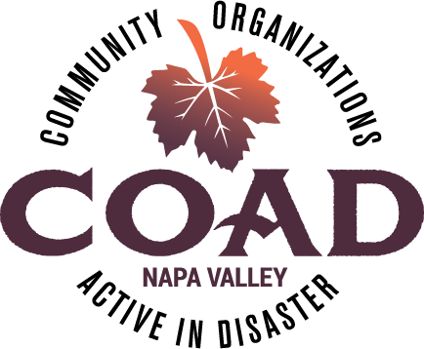
Napa Valley COAD
General Membership Meeting
Tuesday, July 10, 2018 – 10:00 am to 11:30 am
Napa Valley Community Foundation Community Room
3299 Claremont Way #2, Napa

Agenda

Meeting Objectives:
- To network and connect
- To be informed about Public Health’s role in behavioral health during disaster
- To provide training on Crisis Communications Plans

- Welcome and Introductions

- COAD Executive Committee Update
  - COAD Conference Planning Committee
  - AFN Subcommittee call for Co-Chair
  - Update on Long-Term Recovery Group
  - COAD Board of Supervisors presentation – July 31st

- Member Spotlight
  - Napa County Public Health – Role of Public Health in Behavioral Health during disasters

- Member Updates and Announcements

- TRAINING: Crisis Communications Plans, Kelle Kroll
Develop an understanding of the key elements of a crisis communications plan in times of disaster to help prepare your organization. Who are the most important people your agency needs to communicate with in times of disaster? What communication channels will you use and how does your agency prioritize communications? Who is responsible for these communications and what are the roles and responsibilities of a crisis communications team? How does your organization ensure effective communications to non-English speaking clients and others with communication challenges?

- Next Meeting and Adjournment

Next Meeting: Tuesday, August 14 @10:00-11:30 ~ NV Community Foundation Community Room

