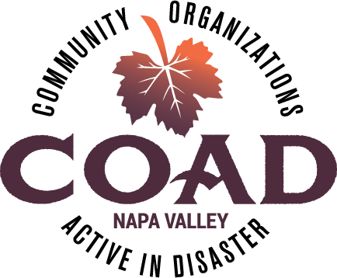
Napa Valley COAD
General Membership Meeting
Tuesday, August 14, 2018 – 10:00 am to 11:30 am
Napa Valley Community Foundation Community Room
3299 Claremont Way #2, Napa

Agenda

Meeting Objectives:
- To network and connect
- To provide training/orientation on “Inclusion of Persons with Disabilities and Others with Access and Functional Needs Into All Phases of Disaster Planning and Operations”

- Welcome and Introductions

- COAD Executive Committee Update
  - COAD Conference Date Change – New Date Thur Sep 27! Anticipate registration email 3rd week of August
  - COAD Conference Planning Meeting
  - NO September COAD Meeting!
  - Events taking place? - Fire Anniversary

- Brainstorming Session on Mutual Aid

- Member Updates and Announcements

- Training/Orientation: A “Whole Community” Approach to Emergency Management: Inclusion of Persons with Disabilities and Others with Access and Functional Needs Into All Phases of Disaster Planning and Operations – Michael Humphries, IHSS Public Authority, Sonoma County

- Next Meeting and Adjournment

Next Meeting: Tuesday, October 9 @10:00-11:30 ~ NV Community Foundation Community Room

See you at the COAD “Stronger Together” Conference on Thursday, September 27th!!

