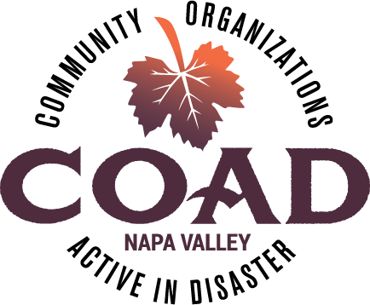
Napa Valley COAD
General Membership Meeting
Tuesday, August 14, 2018 – 10:00 am to 11:30 am
Napa Valley Community Foundation Community Room
3299 Claremont Way #2, Napa

Meeting Notes

Meeting Objectives:
- To network and connect
- To provide training/orientation on “Inclusion of Persons with Disabilities and Others with Access and Functional Needs Into All Phases of Disaster Planning and Operations”

- COAD Executive Committee Update
  - COAD Conference Date Change – New Date Thur Sep 27! Anticipate registration email 3rd week of August
  - COAD Conference Planning Meeting – will take place next week, be on the look for an email with the date. Everyone is welcome!
  - NO September COAD Meeting! (since there will be a conference)
  - Events taking place? - Fire Commemorative events
- Visit Napa Valley - Tracking commemorative events, Catherine will share
- Napa City Fire Department – Fire Prevention Week Oct 7-14, Station 1 having events. Erick will share as info become available
- Community Foundation – Preparing an annual report about the disaster relief fund and it will be available in early October
- On The Move is partnering with Napa Arts Council – planning a commemorative event to share stories/infuse with art and think about community healing
- Suggestions that COAD come up with some messaging thanking first responders and those working in recovery
- Find out if Board of Supervisors is planning anything
- Brainstorming Session on Mutual Aid
- The County EOC is activated if official shelters are opened in Napa County (depending on the size) in support of other counties.
- Some very important aspects to mutual aid is: 1) that there is a formal request for assistance 2) that you document everything correctly so that you can be reimbursed documentation should include logs with labor hours, materials, what was done etc. Volunteer hours also count toward a cost-share. Document, document, document
- CERT teams are a good resource
- Additional sheltering options in Napa specifically geared toward Spanish speaking community
- Napa based agencies can potentially provide technical assistance in implementing emergency assistance funding in neighboring counties.
- It is important to build relationships with neighboring counties.
- There needs to be a process for vetting information that is coming from mutual aid requests.

- Training/Orientation: Power points and handouts included with these notes
A “Whole Community” Approach to Emergency Management: Inclusion of Persons with Disabilities and Others with Access and Functional Needs Into All Phases of Disaster Planning and Operations – Michael Humphries, IHSS Public Authority, Sonoma County

Next Meeting: Tuesday, October 9 @10:00-11:30 ~ NV Community Foundation Community Room

See you at the COAD “Stronger Together” Conference on Thursday, September 27th!!

