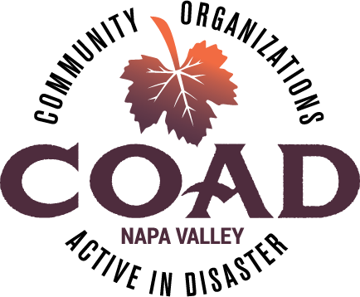
Napa Valley COAD
General Membership Meeting
Thursday, July 10, 2018 – 10:00 am to 11:30 am
Napa Valley Community Foundation Community Room
3299 Claremont Way, Suite 2

Meeting Minutes

- COAD Executive Committee Update
  - COAD Conference Planning Committee
- The conference will be held on September 25th most likely at the Meritage Resort in Napa. If interested in planning, have ideas of subject areas, or have leads on presentors, please let Dorothee know or join the planning meeting on Fri 7/13 from 12-1 at NVCF conference room.
  - AFN Subcommittee call for Co-Chair
- Gina Biter-Mundt has offered to be Co-Chair but we need an additional co-chair to work with her, preferably someone with knowledge/interest in care & shelter. Please conctact Dorothee if you are interested.
  - Update on Long-Term Recovery Group
- The Executive Committee of COAD has been working with the LTR group to offer administrative and logistical support. Looking for an administrative support person for LTR. Please recirculate job description (attached to this email). A consultant is working on gathering the data for the unmet needs so that a case and budget can be made for LTR going forward, anticipated Sep.

  - COAD Board of Supervisors presentation – August (Date TBD)
- Dorothee will be presenting to the Board of Supervisors in August and would love to have COAD members attend. Date will be shared once confirmed.

- Member Spotlight - Napa County Public Health Presentation – Role of Public Health in Behavioral Health during disasters.

- Member Updates
- Califonia Hope will begin terminating services in October and the anniversary of the fires may be a trigger for people – community should be aware.
- On July 28th from 8am until 11 am New Life Tabernacle is hosting a pancake breakfast, benefiting COAD.
- July 28th, Bay Area Legal Aid has attorneys for fire related challenges
- Napa Fire Recovery closed June 30th. Case managers transitioning to working with Catholic Charities for Long Term-Recovery.
- Mentis open house = Thursday, July 12th.

- TRAINING: Crisis Communications Plans, Kelle Kroll – materials attached

Next Meeting: Tuesday, August 14th @ 10:00 – 11:30 ~ NV Community Foundation Community Room

