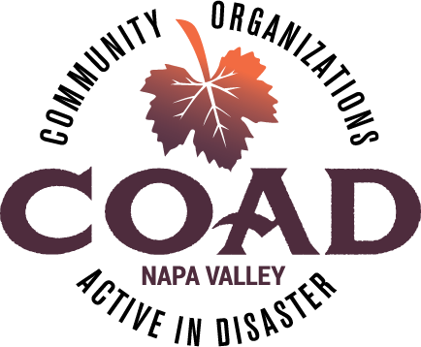
Napa Valley COAD
General Membership Meeting
Tuesday, January 15, 2019 – 2:00 pm to 4:00 pm
Napa Valley Community Foundation Community Room
3299 Claremont Way, Suite 2

Meeting Minutes

- Welcome and Introductions

- Subcommittee Updates
Public Info/Outreach – Communicating with Spanish Speakers in Times of Diaster
- Alissa from On the Move reported that the big goal has been in creating content for the tool-kit that will be relevant and useful. We have been working with a Communications consultant and including input from various community stakeholders. We are in the final stages of completing the tool-kit. The guide includes case studies from other counties. The toolkit is being vetted but if anyone wants to review, please let Dorothee know. Working with graphic designer to make it user friendly and visually appealing. Circulating it by the end of February.

Animals
- Wendi from Napa Humane reported that Napa CART is hosting quarterly meeting with a the animal welfare organizations ans a majority of the orgs are participating in the meetings. Napa CART is also holding monthly animal specific trainings. The big push is to have trained volunteers so that we are ready to activate for the next disaster.

Care, Shelter and Acess & Functional Needs
- Nathan from Long Term Recovery is willing to co-chiar this committee but is looking for another co-chair and additional committee members. Please let Dorothee know if interested in joining this committee. The subcommittee will be meeting with Napa County at the end of January to get updates on current County plans and improvements and how COAD may be able to add value to shelter and AFN planning.

Long-Term Recovery Group
- Nathan reported that bylaws have been revised and approved.
- The name has changed from Napa Fire Recovery to Napa County Disaster Recovery.
- About to launch outreach campaign to try and reach people affected by the fires who may still need assistance.
- LTR has an active subcommittee groups: construction, housing, disaster case management, communications, mental health and spiritual care, volunteers and donations, unmet needs. Looking for a chair for fund development and finance committee.
- February 7th at time TBD for Fire Survivors Support Group.

- COAD Executive Committee Update
- Meeting Schedule for 2019. We are meeting every other month now - dates are March 19, May 21, July 16, Sep 17, Nov 19. Everyone should have received calendar invite updates already – if you didn’t please let Dorothee know.
- Tabletop Exercise – At the next COAD meeting on March 19 we will be doing a table-top exercise of a COAD Activation, meaning practicing what we would do/how we would activate the COAD if there were to be a disaster. Consultant Kelle Kroll will be here with us working through a scenario and exercise. We will be sending out more information later in February.
- Final Interviews with potential fiscal sponsors - We have interviewed two agencies to be the new COAD & Long-Term Recovery Fiscal Sponsors. Those are the Social Good Fund and Bay Area Community Resources. Final decisions will be made by the Executive Committee at the end of this month.

- COAD Website Review
- About Us – list of all of the organizations involved in COAD. The Resource Directory that outlines what services you provide can be found here. If your organization isn’t listed, be sure to have it added.
- Meetings – General meetings has the dates up upcoming meetings but also has the minutes from past meetings.
- Trainings and Workshops – if presenters were willing to share their slides and notes, they can be found here.
- Disaster Operations – links to the same Resource Guide found in About Us.
- 2017 Fire Recovery – currently has a link to contact Nathan at LTR. By the end of February we hope to have an extensive page with LTR resources.
- Resources – information on preparedness. Would like to have the resources page be in Spanish.
- During times of disaster the website will be the portal for up to date information about meetings dates and times.
- News and Events can be linked to flyers or linked to individual organizations websites. Can add a widget to the website so that news and events links directly to facebook.

- Member Updates and Announcements
- Catherine Haywood – Leadership Napa Valley has a practicum that is creating a welcome wagon for people new to Napa and they want to ensure that COAD is included on that list.
- Jim Tomlison stated that MLK Day is a big community volunteer day and you can post opportunities on the CVNL site.
- Jameson Animal Rescue Ranch is providing annual spay/neuter, vaccines and microchipping at Crosswalk on MLK Day.
- In Feb 2019 is the first-ever Indinginous language day. Good opportunity to be reminded of indingionous languages – many indigenious languages are spoken here in Napa. Working on providing translation for indigenous languages.

- Personal Preparedness Workshop – Red Cross
- Slides from the presentation included with notes and can be found on COAD website.

Next Meeting: March 19. 2019 @ 2:00 pm to 4:00 pm ~ NV Community Foundation Community Room

