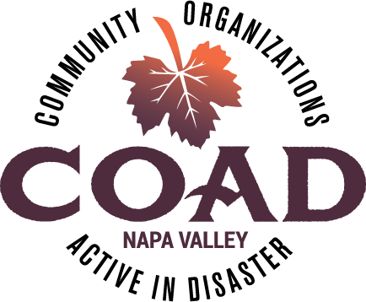
Napa Valley COAD
General Membership Meeting
Tuesday, November 13, 2018 – 10:00 am to 11:30 am
Napa Valley Community Foundation Community Room

Agenda

Meeting Objectives:
- Introduce COAD Disaster Activation Plan
- Planning & Prioritizing for 2019
- Update on Current Activities

- Welcome and Introductions

- COAD Conference Debrief

- Long-Term Recovery Update & Meet the New Director

- Internews Grant: Communicating with Spanish Speakers in Times of Disaster

- COAD Disaster Activation Plan & Keeping your agency up-to-date

- 2019 Training & Event Priorities

- Meeting Schedule for 2019

- COAD Executive Committee: Strategic Planning

- Member Updates and Announcements

Next Meeting: SEE YOU IN JANUARY 2019….

