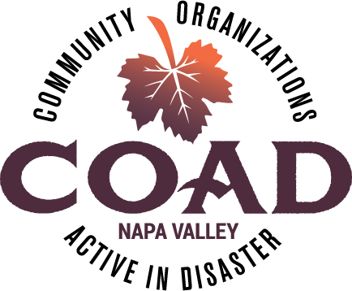
Napa Valley COAD

ACTIVATION MEETING – COVID-19

Tuesday, March 24 at 9:45AM via Zoom

AGENDA

Meeting Objectives:
- Share COAD’s operation objectives
- Share communication flow and protocols
- Review Subcommittee Structure for COAD’s response to COVID-19
- Review member and subcommittee roles and responsibilities
- Describe subcommittee purpose and initial objectives
- Sign up for subcommittees

- Welcome

- Ground rules and how the virtual meeting will work

- Introductions

- COVID-19 – Situation Status

- COAD Operational Objectives

- COAD/EOC Communication Flow

- Subcommittee Structure under ICS principles
  - Communication protocols

- Roles and Responsibilities
  - Subcommittee CO-Chair roles and responsibilities
  - COAD member roles and responsibilities

- Subcommittees
  - Subcommittee Descriptions
  - Signing up for a subcommittee

- Meeting schedule

Adjournment – NEXT MEETING - TUESDAY, APRIL 7, 2020 at 11AM

