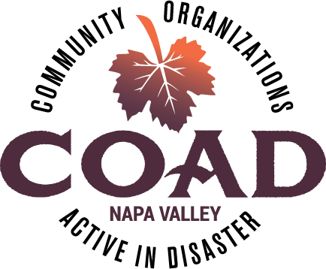
Napa Valley COAD
General Membership Meeting
Tuesday, JANUARY 21 – 2:00 pm to 4:00 pm
Napa Valley Community Foundation Community Room

Agenda

Meeting Objectives:
- Preview of 2020 COAD General meeting topics
- Learn more about Napa’s Emergency Operation Center – its organization and operations
- Subcommittee and work group updates

- Welcome introductions - please be sure to sign in!

- Executive Committee Updates
- New executive committee member!
- Strategic planning process underway

- COAD 2020 meetings preview – see handout

- Presentation by Napa County OES and Public Health on EOC organization and operations
Presenters:
- Kevin Twohey, Napa County Office of Emergency Services - EOC Manager
- Lisa Fletcher, Public Health – EOC Plans Chief
- Shaun Vincent, Public Health/EMS – EOC Medical Health Branch Director

- Subcommittee Updates
  - NEW - Emergency Food Preparedness working group
  - AFN/Shelter & Care – new Chair Marlena Garcia
  - Public Information & Outreach
  - Disaster Recovery Group – Forum conducted January 10, survey responses due January 24
  - Sheltering Children working group – next meeting is January 29, 9:30 at CrossWalk Church

- Member Updates & Announcements

Next Meeting: Tuesday, MARCH 17, 2020 @ 2:00pm-4:00pm
LOCATION – TO BE ANNOUNCED – Look for an updated calendar invite in February

