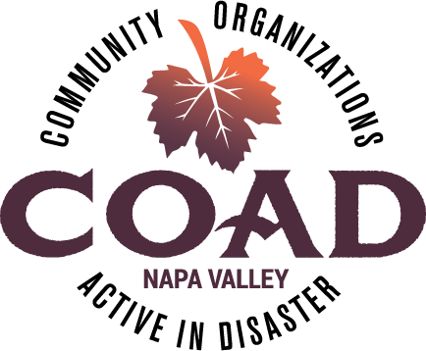
Napa Valley COAD
General Membership Meeting
Tuesday, January 15, 2019 – 2:00 pm to 4:00 pm
Napa Valley Community Foundation Community Room

Agenda

Meeting Objectives:
- Update from Subcommittees
- Review of COAD website
- Learning to be better prepared for disaster (Personal preparedness)
- Connecting & Networking

- Welcome and Introductions

- Subcommittee Updates
  - Public Info/Outreach - Communicating with Spanish Speakers in Times of Disaster
  - Animals
  - Care, Shelter and Access & Functional Needs
  - Long-Term Recovery Group

- COAD Executive Committee Update
  - Meeting Schedule for 2019
  - Tabletop Exercise – COAD Activation March 19!
  - Final Interviews with potential fiscal sponsors

- COAD Website Review

- Member Updates & Announcements

- Personal Preparedness Workshop – Red Cross

Next Meeting: March 19, 2019 @ 2:00pm-4:00pm

