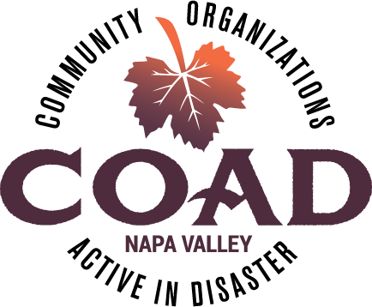
Napa Valley COAD
General Membership Meeting
Tuesday, March 19, 2019 – 2:00 pm to 4:00 pm
Napa Valley Community Foundation Community Room

Agenda

Meeting Objectives:
- Presentation of “Communicating with Spanish Speakers During Disaster” Guide
- Updates from Subcommittees
- COAD Activation Table-Top Exercise – Beginning Stages

- Welcome and Introductions

- Presentation of “Communicating with Spanish Speakers During Disaster” Guide – COAD Public Info & Outreach Subcommittee

- Subcommittee Updates
  - Care, Shelter and Access & Functional Needs
  - Long-Term Recovery Group

- COAD Executive Committee Update
  - New Fiscal Sponsor starting April 1
  - Executive Committee Vacancy – Call for Nominations

- Member Updates & Announcements

- Table-Top Exercise: COAD Activation – Beginning Stages led by Kelle Kroll Group

Next Meeting: May 21, 2019 @ 2:00pm-4:00pm

