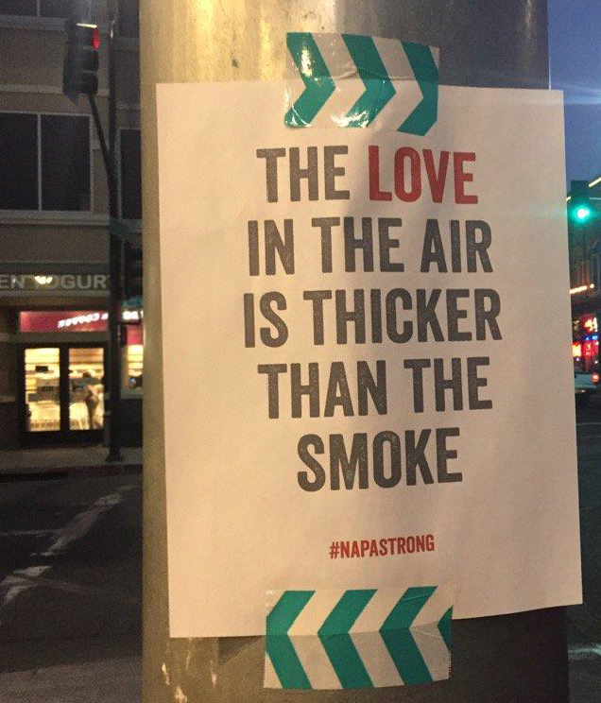
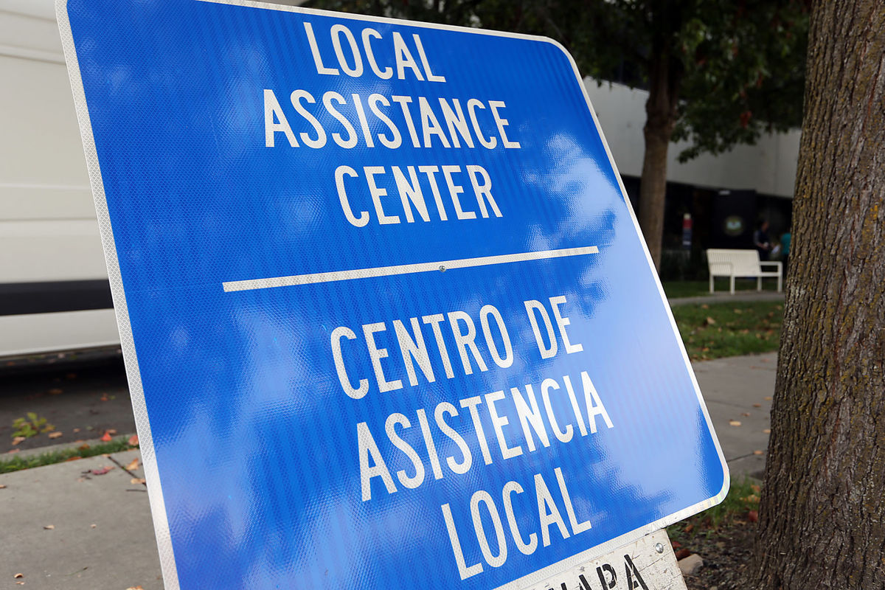
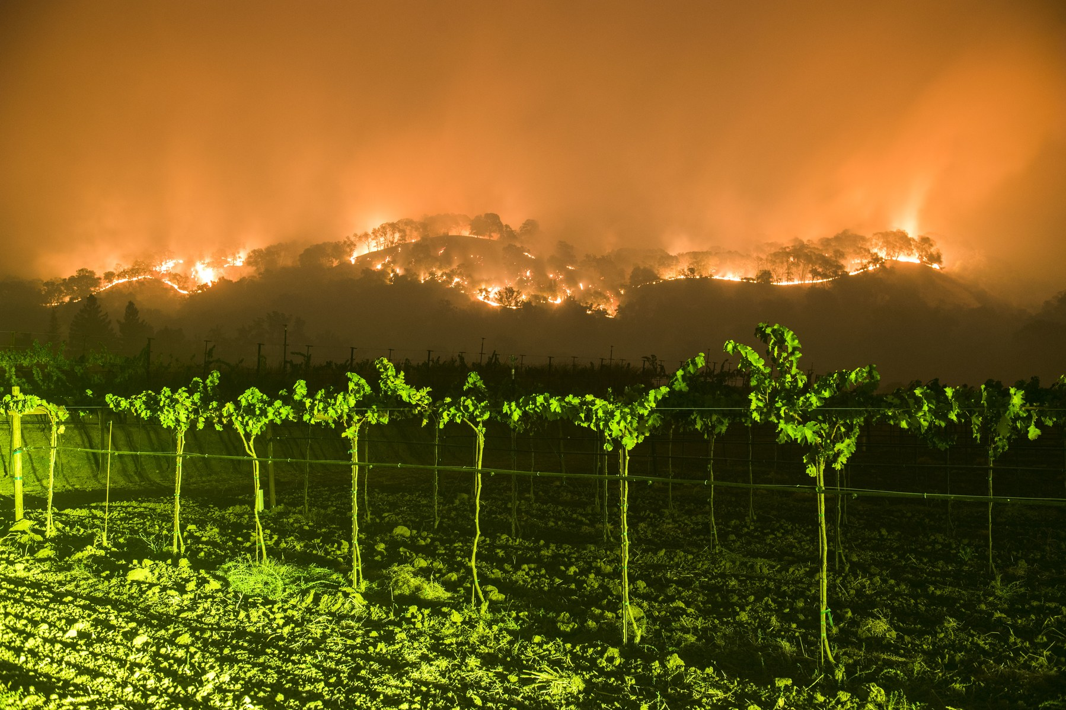
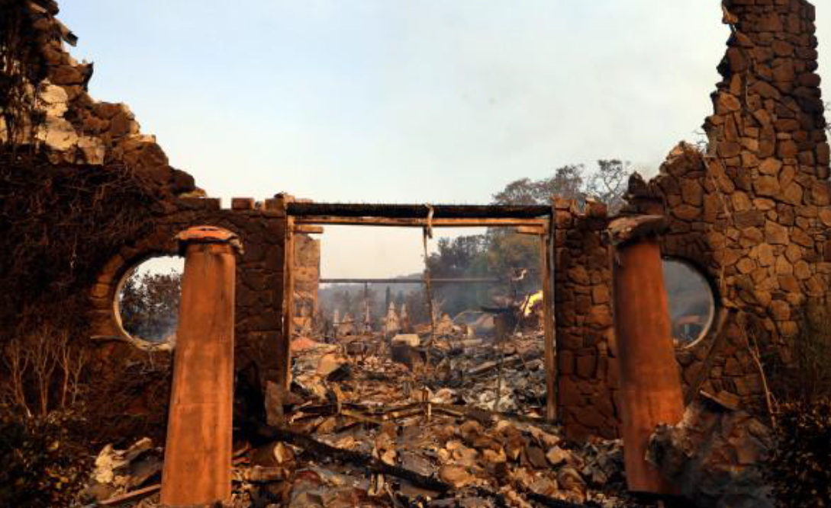
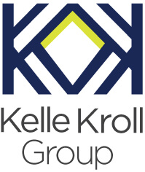
Prepared by:
Kelle Kroll Group
22 Charles Street, Los Gatos, CA 95032
408.356.0184
kelle@kellekrollgroup.com
www.kellekrollgroup.com

North Bay Fires After Action Report for
Napa Valley COAD
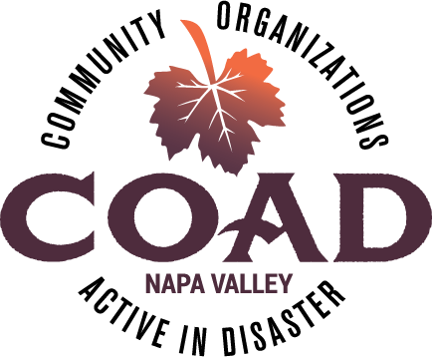

Table of Contents
After Action Overview 3
1. AAR Design Summary 4
1.1 AAR Purpose and Design 4
1.2 Methodology 4
2. Summary of Findings – COAD 5
2.1 COAD Strengths 5
2.2 COAD - Areas for Continuous Improvement 7
2.3 COAD Recommendations 8
3. Summary of Findings – Agencies 9
3.1 Agency Strengths 9
3.2 Agency Areas for Continuous Improvement 10
3.3 Agency Recommendations 11
Conclusion 12
Appendix A: Interview Questions 13
Appendix B: COAD Fire Complex Meeting Agendas 14
Appendix C: COAD Media Interviews 15

After Action Overview

Napa Valley Community Organizations Active in Disaster (COAD) was in its inception when numerous fires, named the 2017 Napa Fire Complex broke out on October 8, 2017. These were some of the fastest moving and most destructive fires in California history. COAD activated its newly created COAD Liaison position within the Napa Valley Emergency Operations Center (EOC) on Monday, October 9th.

On October 10th, the fires were declared a Federal Disaster. In Napa County, the Atlas, Tubbs and Nuns Fires burned a total of 69,979 acres, destroyed 1,221 structures and resulted in 7 fatalities. Within days of the incident, Recovery Operations planning began. On October 23, Emergency Operations officially transitioned to Recovery Operations. The EOC was operational for 16 days and was operated by a total of 97 staff members including county employees and partner agencies. The fires were contained on October 31st. The COAD Liaison was active during both the Emergency and Recovery Operations of this event.

The Local Assistance Center opened at Napa County Health & Human Services Agency South Campus. COAD took lead for setting up and organizing the non-profit campus of the Local Assistance Center (LAC) and many key COAD agencies staffed the LAC for long hours over 15 days as it remained open 7 days a week.

COAD was a critical channel for collecting and sharing up-to-date information and coordinating response activities between the COAD agencies and local government. Since at the time of the fires, communications platforms for the COAD had not yet been put in place, COAD quickly established a Facebook page and dedicated Gmail account for COAD response communications. COAD engaged state and federal partner agencies to enable the distribution of timely information. COAD convened meetings following the fires, the first one on Day 3 of the event and organized ten meetings between the day the fire broke out and December 31, 2017.

The following After Action Report (AAR) is an analysis of the COAD efforts in the response, relief and initial recovery phases of this disaster. COAD is still actively involved in the recovery phase and plans to continue to play a critical role in communication and coordination amongst the broader Napa community.

Napa Valley COAD Mission Statement
In Napa County, Community Agencies Active in Disaster (COAD) is on a mission to develop and enhance partnerships for communication, coordination, and collaboration amongst the whole community including nonprofit and faith based organizations, government agencies and the private sector during all phases of a disaster.

AAR Design Summary

AAR Purpose and Design
KKG designed this AAR to act as a tool to identify strengths, areas for improvement and recommendations based on COAD’s response to the October 2017 North Bay Fires. As part of a larger continuous improvement process, the findings from the AAR will allow COAD’s leadership team to take the actions needed to develop and improve strategic planning goals, build and sustain capabilities, identify key areas for growth, both in the Recovery Phase of this event and for the long-term future of COAD.

Methodology
The design of the after-action plan included information gathered via the following:

- Survey of COAD Members– A detailed survey was sent to the entire COAD distribution list and can be found in Appendix A. The survey asked members to assess the ability of the COAD and their individual agencies to respond during and after the fires, focusing on strengths and challenges. A total of 19 members responded with the option of responding anonymously although most chose to list their name and organization. The survey respondents demonstrated a strong cross-sector representation with participants from non-profits, local government, private sector and faith-based agencies.
- Document Review - A review of written documents developed during the response, meeting notes, incident logs, media articles and COAD email communications.
- Interviews - In person and phone discussions with key stakeholders.

This After Action report is a compilation of information collected from the above sources, and includes sections on strengths, areas for continuous improvement and recommendations. The report findings are broken out into two sections – Section 2 is focused on the COAD as a whole and Section 3 is focused on findings relative to individual agencies.

Summary of Findings – COAD

COAD Strengths

“Once the fires started, the COAD jumped into action and every meeting was incredibly valuable. The meetings created a sense of unified community between organizations, provided information directly from the EOC that we may not have received otherwise. We were able to communicate directly with other organizations to share resources and ensure that we weren’t duplicating services, and we were able to problem solve issues.”

    - Having a dedicated liaison position for COAD in the Napa County EOC with an experienced disaster response person who understands EOC Operations allowed COAD to hit the ground running from day one of the response after the fires broke out. The COAD Liaison knew how to engage the appropriate local, state and federal partners and quickly put into action mechanisms to share information from the EOC with the COAD agencies and amongst the COAD members.
“Having a dedicated EOC COAD liaison was very valuable.”

“The COAD Liaison position was staffed in the County EOC, attended daily briefings which improved communication with partner agencies throughout the incident.”

“

    - Conducting frequent in-person meetings of the general COAD – many participants emphasized the value of in person meetings, especially during such a prolonged activation with power and cell service outages and how important the meetings were for information sharing, coordinating resources, avoiding duplication of services and addressing gaps in services.
“I was able to obtain accurate and reliable information – in person meetings so that information updates were happening in real time, especially with many of us with no Internet or cell reception. In person meetings were critical.”

“The meetings provided a way to communicate during and post disaster about the changing landscape.”

“The resources coming together in one place were invaluable. We shared these resources available throughout the community with our visitor serving businesses, many of which are small businesses.”

“Bringing our community organizations together as soon as the fires began was most valuable to me. That sense of community, working together and never feeling alone was incredibly valuable.”

    - After the first meeting, which took place on day three of the fires, the COAD was able to help with operational solutions through engagement of member agencies. An example of this was the challenge agencies were facing with childcare for employees. Schools were closed and in a prolonged evacuation phase, the uncertainties of when the fires would be contained caused many parents to not want to leave their children. The Boys and Girls Club on day four offered to send childcare providers to agencies in order to provide onsite care so that staff could continue to serve their clients. With so many people evacuated and impacted, staff resources were invaluable and many agencies faced staffing shortages.
“ Networking of resources and the building of relationships with other non-profits that would be "first responders" in a disaster.”

“The most valuable function of COAD was bringing awareness of the need of non-profits to step up and band together in an emergency. We are generally agency focused and we need to be more community focused”

    - Having a central and coordinated place to share information, especially emergency information from the EOC and to understanding emerging resources and community needs.

“COAD was our most up-to-date source of information.”

“COAD’s most valuable function was providing information from the EOC and linking to state and federal resources and best practices in a disaster.”

2.1.5 Many respondents mentioned how valuable the COAD communication tools were - COAD established immediate communication tools by establishing a Facebook page, Gmail group distribution, cell phone lists to enhance rapid communication amongst members and from government partner agencies. COAD also began designing a website during the fire response which is currently under construction.

COAD - Areas for Continuous Improvement

“I think there has probably been a lot of turnover since the disaster planning start 2 years ago. Ongoing agency preparedness and updating of the disaster plan would be important.”

“Help with agency communication plan including clients, board and staff”

“Training in the functions and parameters of the EOC”

    - Develop stronger coordination of public information from COAD to agencies, partner organizations and County and City Public Information Officers. COAD needs to establish clear messaging in both English and Spanish at the onset of the event.
“Having the correct information is important and to have an equal communication breakdown in English and Spanish. It is so important the information flow is getting to the right people and we need to build stronger ties with our County and City PIOs.”

    - Provide better assessment and support to people with Access and Functional Needs in evacuation centers, shelters, volunteer centers, in-kind donation centers and other services provided to fire survivors.
    - Strengthen closer coordination with UpValley to help meet the needs of the entire county. This was an overall area identified for improvement following the 2014 Earthquake and it has improved in the Lake County Fire and Napa 2017 Complex response. However, given the many clients and needs in the UpValley, it will be important for COAD to consider meeting schedules, location, etc. to develop a holistic and inclusive process for integrating organizations from UpValley.

COAD Recommendations
    - Develop public messaging templates in English and Spanish working with the County and City Public Information Officers that can be adapted and utilized at the onset of an event.
    - Make Access and Functional Needs a high priority item for COAD and develop processes and procedures to develop advocacy and support for AFN populations in emergency operations.
    - Provide training to COAD agencies on how to conduct emergency exercises and drills; how to train-up new staff and develop an effective strategy for plan maintenance and updates.
    - Facilitate and engage in multi-agency training and exercises with local government, faith-based organizations and the private sector.
    - Develop a plan to conduct meetings and activities to be accessible and inclusive of all of Napa County, including UpValley.
    - Analyze best practices and convene discussions to bolster a strong and resilient recovery. COAD could bring a “think tank capability” to many issues that some impacted communities or individual agencies may not have the bandwidth to tackle and help with gathering, planning and convening discussions on potential topics below:
  - Workforce Development resources
  - Convene conversations around “Equity for Recovery”
  - Housing – both Interim Housing and Long-Term Housing. Affordable housing and availability of housing issues that existed previously - what are re-building models that may help address these issues?
  - Trauma Informed Care – identifying and accessing mental health resources
  - How to increase outreach and preparedness of immigrant and migrant communities
  - How to retain more vulnerable populations such as agricultural workers, teachers, hospitality staff, firefighters who were directly impacted, etc. who may be under insured and not have the resources to rebuild.

    - Provide meeting materials such as PowerPoints and handouts to participants prior to the COAD meeting or utilize “Go To Meeting” so that members participating by phone can more easily follow and contribute to the discussion.

Summary of Findings – Agencies

Agency Strengths

    - Many agencies that had an Emergency Operations plan in place were able execute it quickly and effectively and it provided clear information on roles and responsibilities.
“Our agency was prepared and ready to assist the community because we had a complete disaster plan prepared, staff communication channels ready and available, and clear direction of our role in response and recovery.”

Before the COAD came the Community Foundation sponsored disaster preparedness (EOP) trainings that Napa Humane was thankfully a part of. Before these trainings, very little thought had gone in to disaster planning. It had always been an organizational goal, but as is often the case, remained low on the priority list. The trainings forced us to elevate its importance and we spent a year focusing on disaster preparedness and response.

    - By being prepared with an EOP in place, COAD agencies were able to fulfill their role in the disaster as well as continue their day-to-day operations
“My agency is strong, I have a great team, we have the essential resources to do a good job in handling the disaster without having to disrupt our regular work too much. That we could be there to support other agencies and our clients.”

“Our coordination with community partners was stronger than expected”

    - COAD agencies across the board demonstrated an appreciation for the dedication and tireless efforts of their staff and colleagues working long hours to serve clients, even when some of them were impacted by event. Many noted the sense of community coming together for the greater good.
“The most powerful aspect of this incident was the compassion displayed by our staff and the residents, the community pulling together.”

“The camaraderie of the staff working at the Local Assistance Center and the thankfulness and hope of the people we served.”

Agency Areas for Continuous Improvement
    - More training and exercises are needed to keep individual agency staff familiar with emergency operations and address turnover within the agencies.
“We need to run a yearly emergency drill. We would like training on how to run a drill with our staff.”

“I would like the COAD to have a comprehensive list of available trainings - CERT, FEMA, etc. and then come up with additional trainings that will likely be identified from orgs via this survey. I think a current hole is addressing functional needs. Our agency doesn't need assistance with recovery efforts for the org, but the COAD will for sure play a role in helping my org best serve our community during LTR. The collaboration among organizations is critical and the COAD does a great job of bring the organizations together.

    - Agencies need more staffing redundancy and to develop back-up options for staffing their organizations.
“The most significant thing that I hadn’t taken into consideration when writing the EOP was just was just how many employees in our organization would not be able to show up for work. Due to the terrible air quality and the schools being closed, many employees had to either stay home with their children, leave town, or were evacuated. This left us very short staffed.
“We need to include volunteers more in our disaster plan. We need to train them to be a part of our disaster team. As a small organization with few staff, I realize just how critical that piece is.”

    - Consider engaging contractors and/or new staff to ramp up response capacities.
“All of our staff were redirected to disaster response. We actually should have engaged new staff to work on the disaster response.”

    - Planning for back-up communications when power and cell towers go down for both internal and external communications.
“Our partnerships and learnings from past disasters made our response stronger; we need to consider better back up response when phone towers go down; we need improved and timely messaging for immigrant populations with trusted organizations and better coordination with cities and schools.

Agency Recommendations
“Be prepared and have a communication plan between family members”

“Preparation is key; have a back-up method of communication.”

    - Develop a regular plan for exercises, training and plan maintenance and updates. Incorporate disaster responsibilities into staff job descriptions and provide education on personal and family preparedness for staff so they are more capable of responding to your disaster mission.

    - Develop resources to increase staff capacity for your agency by engaging and training volunteers, developing mutual assistance agreements with other organizations who provide similar services, establishing emergency contracts with vendors and further engaging board members in emergency operations as appropriate.

    - Plan for back-up communications, check-in sites and alternate locations if facilities are not accessible.

Conclusion
What is the greatest lesson learned from these fires?

“The sense of community. I kept saying that "this has been the most horrible and yet the most beautiful experience."

“That material things will never be as important as the safety of our family and friends.”

“Take care of your family’s needs first – you will need their full support as you work around the clock.”
“Pace yourself, take care of staff, do the best you can, don't take things personally, train your staff on the EOP/COOP so they are aware of the organization's role in a disaster.”

“Life is precious.”

After the Thomas Fire broke out in Ventura shortly after the North Bay fires, Governor Jerry Brown visited the site and noted:

“This is the new normal,” Brown said, in a news conference after his tour. “We’re facing a new reality where fires threaten peoples’ lives, their properties, their neighborhoods and cost billions and billions of dollars. We have to have the resources to combat the fires, and also have to invest in managing our vegetation and forests and all the ways we dwell in this very wonderful place — but a place that’s getting hotter.”

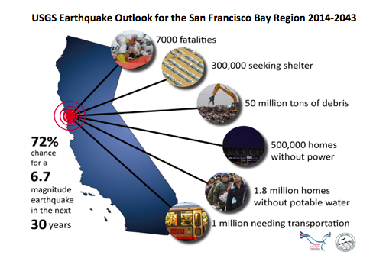
In summary, the response and relief phase of COAD’s efforts were extremely successful and helped identify an opportunity for providing meaningful and time sensitive communication and coordination.

Despite an unprecedented number of activations in Napa County three years in a row, the risk factors for all types of disasters in California are increasing daily. The Bay Area constantly plans for the big earthquake – the Bay Area has a chance of 72% or higher for a quake the size of the Loma Prieta earthquake. However, global warming is bringing additional high risk to California for fires and flooding, the past two years have dramatically brought evidence of these risk factors. COAD has an opportunity to put a lens on disaster priorities that are often overlooked by day-to-day priorities – how to plan for increasing resilience for all of the COAD agencies and the entire Napa community.

Appendix A: Interview Questions

Napa Valley COAD After Action Report Questions
Fire Complex 2017

Organization: ___________________________________________________________________
Name: ___________________________________________________________________________
What was your role in this response? _________________________________________

COAD Questions:
- How did COAD’s activation and role assist your agency in this incident response?
- What was the most valuable function of COAD for your agency?
- What additional role could COAD have played to better assist your organization?
- How could COAD improve to become more effective for the next incident?
- What types of training could COAD provide in the upcoming year to help your agency with recovery efforts and/or become better prepared for the next disaster?
- What role do you think COAD should play in Long Term Recovery for this incident?
Organizational Questions:
- What worked well for your organization’s response to this incident compared to previous activations?
- What resources or tools helped you organize your agency’s response?
- Are there any staff that weren’t involved but may have helped increase your organizational response capabilities?
- Did you utilize the Incident Command System and or Emergency Coordination Teams developed in your Emergency Operations Plan (N/A if you do not have an emergency operations plan)
- If you had to write a job description for the role you played in this response looking towards improvements, would it be different from the actual role you played? If so, how? (Please have every person on your staff who played a significant role answer this question)
- Do you feel you and your family were adequately prepared to evacuate?
- If not, what would you do to become more prepared?
- Overall – What could be improved?
- What is the most significant lesson or lessons learned for your organization from these fires?

Individual Questions:
- What is the most powerful aspect of this incident that has stayed with you?
(Prominent thoughts, moments, memories)
- Do you feel you and your family were adequately prepared to evacuate?
- If not, what would you do to become more prepared?
- What is the greatest lesson learned for you and your significant others from these fires?

Appendix B: COAD Fire Complex Meeting Agendas

Appendix C: COAD Media Interviews

