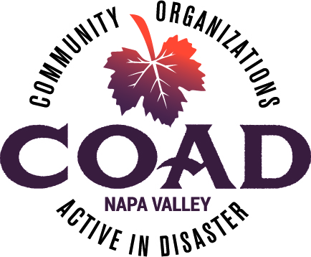
NAPA VALLEY COAD
COMMITTEE
OPERATING GUIDE

UPDATED JANUARY 2026
TABLE OF CONTENTS
Contents
SECTION I – COAD’s ROLE, STRUCTURE & LEADERSHIP PRINCIPLES 3
INTRODUCTION 3
COAD MISSION AND VISION 3
COAD OVERVIEW 4
COAD STRUCTURE 4
COAD’s ROLE IN ALL PHASES OF DISASTER 5
COAD LEADERSHIP PRINCIPLES 6
SECTION II - COAD OPERATING PRINCIPLES & PRACTICES 9
HOW COAD OPERATES 9
OVERVIEW OF INCIDENT COMMAND SYSTEMS (ICS) 9
HOW COAD INTEGRATES INCIDENT COMMAND PRINCIPLES 10
COAD INCIDENT COMMAND ROLES 11
SECTION III – COAD ACTIVATION PROCESSES 12
COAD ACTIVATION PROCESS 12
ROLES & RESPONSIBILITIES IN AN ACTIVATION 14
COMMUNICATION PROTOCOLS & FLOW DURING A DISASTER 16
COAD COMMITTEE ADVISORY COUNCIL 17
SECTION IV – COMMITTEE LEADERSHIP & RESPONSIBILITIES 18
BEING A COLLABORATIVE LEADER 18
LEADING DURING TIMES OF CRISIS 20
COAD COMMITTEE SPAN & SCOPE OF CO-CHAIR RESPONSIBILITIES 21
COAD COMMITTEE LEADER CHECK-IN MEETINGS 22
AFTER-ACTION REPORTING 23
SECTION V – COAD COMMITTEES: GETTING STARTED 24
RECRUITING COAD COMMITTEE MEMBERS 24
GETTING STARTED WITH YOUR COAD COMMITTEE 25
COMMUNICATION AND MEETING TEMPLATES 26
SECTION VI – COAD COMMITTEE MEETINGS: FACILITATING EFFECTIVE MEETINGS 27
WHEN AND WHY TO MEET 27
FACILITATING EFFECTIVE MEETINGS 28
SECTION VII – SHARING THE WORKLOAD 31
STRATEGIES FOR SUCCESSFULLY SHARING THE WORKLOAD 31
STRATEGIES FOR SHARING THE WORKLOAD WITH VOLUNTEERS 31
A DEVELOPMENTAL MODEL FOR ASSESSING ABILITIES WHEN DELEGATING 32
DEVELOPMENTAL MODEL FOR DELEGATION 33
IDENTIFYING AND ASSIGNING ROLES 34
SECTION VIII – DECISION MAKING AND CONSENSUS BUILDING 34
DECISIONS WITHIN THE PURVIEW OF SUBCOMMITTEES 35
TYPE OF DECISIONS 35
CONSENSUS BUILDING 36
DECISION MAKING STEPS 37
SECTION IX – TRACKING & STORING YOUR COAD COMMITTEE WORK 38
TRACKING THE WORK OF YOUR COMMITTEE 38
STORING & SHARING COMMITTEE INFORMATION – DROPBOX 39
SECTION X - APPENDICES 41
APPENDIX 1 42
COAD COMMITTEE DESCRIPTIONS DURING ALL PHASES OF DISASTER 42
APPENDIX 2 – COAD ACTIVATION SEQUENCE 56
FIRST 12 TO 24 HOURS 56
APPENDIX 3 -SETTING OPERATIONAL OBJECTIVES 57
APPENDIX 4 – AFTER ACTION TEMPLATE 59
APPENDIX 5 – SAMPLE CO-CHAIR MEETING AGENDA 63
APPENDIX 6 – SAMPLE COAD COMMITTEE MEETING AGENDA 64
APPENDIX 7 65
COAD DISASTER ACTIVATION GUIDE – Updated April 2024 65
APPENDIX 8 – COAD RESOURCE GUIDE 66

SECTION I – COAD’s ROLE, STRUCTURE & LEADERSHIP PRINCIPLES

INTRODUCTION

The COAD Committee Operating Guide is designed to be a resource for Committee Leaders and members to better understand COAD’s role, especially during a disaster response, and how to effectively work within a committee to meet shared objectives. This guide is a living document and will be updated regularly based on needs and operational changes.

COAD MISSION AND VISION

The work of COAD is guided by its mission, vision, purpose, and values. Our mission describes our overarching purpose, while our vision describes what it looks like when we achieve our mission. Our values describe the principles we bring to our work and purpose statements reflect how we work toward our mission.
Mission: COAD develops and enhances partnerships for communication, coordination, and collaboration amongst the whole community including nonprofit and faith-based organizations, government agencies, and the private sector, during all phases of disaster (response, recovery, mitigation, and preparedness).
Vision: COAD envisions a community where all members are equitably prepared for disaster so all have an equal opportunity to survive and recover from a disaster.
COAD Values: Collaboration and cooperation, equity and inclusion, cultural sensitivity, dignity and respect for each person’s experience, and meaningful engagement with partners and the community.

COAD Purpose Statements:
COAD’s purpose is to provide leadership to the nongovernmental response during all phases of disaster by creating linkages across all sectors and providing effective coordinated efforts to promote community resilience. COAD prioritizes households with limited financial resources and community members with access and functional needs.

- COAD is an inclusive coalition, which strategically networks its autonomous member organizations to maximize the broader community’s capacity for disaster mitigation, preparedness, response, and recovery.
- Central to effective coordination is vetted, timely communications and collaboration to minimize the duplication of services to maximize available resources.
- COAD works to complement government efforts, not duplicate their services.
- COAD is not a direct service provider during an emergency response but focuses on effectively coordinating the work of member agencies and subcommittees to ensure collaboration, to minimize the duplication of services, and maximize available resources.
- In preparedness work, COAD is a direct provider of preparedness education and promotes community resilience through its Meet Your Neighbor program.
- After-action analyses are integral to COAD’s work for mitigation planning and preparedness for future responses.

COAD seeks to be a community leader in all phases of disaster helping to build a more resilient and self-reliant Napa County. COAD works toward equitable practices to ensure consistent and systematic just, fair, and impartial treatment, especially for underserved and marginalized populations. Equity acknowledges that we do not all start at the same place and that adjustments need to be made for imbalances. Equity work is ongoing and seeks to identify and remove barriers. (Executive Order 2021)

COAD OVERVIEW

As a leader in all phases of disaster, COAD is not a competing or exclusionary organization; rather it is intended to be a coordinating body and network for organizations involved in all phases of disaster. Each COAD member organization retains its own authority, independence, and identity, while closely collaborating with other COAD member organizations.

COAD’s work revolves around three primary functions:

- Communication – Develop and maintain effective channels of accurate, vetted, timely communication for member organizations, especially during activations, and amplifying County messaging to the public.
- Coordination – Stand up subcommittees to coordinate the response of second responders and other nongovernmental agencies to ensure an effective response that identifies gaps and avoids duplication.
- Collaboration – Identify common goals and create shared solutions to meet needs during all phases of disaster. Work with the County and other partners to create collaborative and complementary efforts.

COAD STRUCTURE

The chart below outlines COAD’s organizational structure, particularly during a response, and its relationship to the County’s Office of Emergency Services, which runs the Emergency Operation Center (EOC) during a disaster activation. The County EOC leads the government response and looks to COAD and its committees to provide community services outside its scope. COAD’s Liaison role in the EOC is a critical source of vetted, real-time incident information to share with agencies as COAD develops and implements its coordinated response. Critical roles within COAD’s coalition include:
Board of Directors (BOD) - The Board of Directors oversees COAD’s operations and has final decision-making authority. COAD’s bylaws provide the foundation for organizational governance.
Executive Director – The Executive Director leads COAD’s work during all phases of disaster including response, long term recovery and preparedness. Typically, the ED serves as the main liaison and disaster coordinator during a disaster response
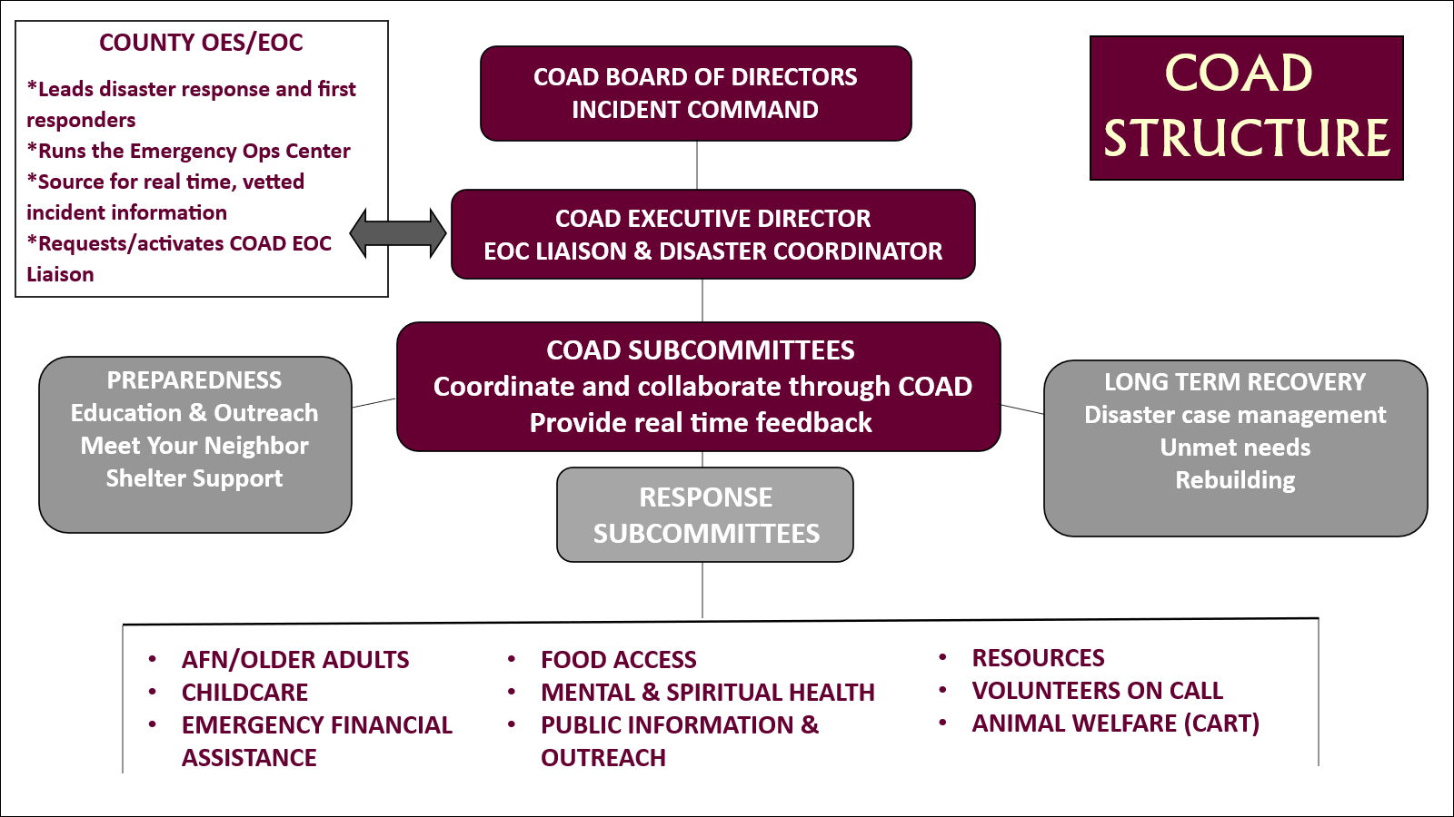
COAD Committees – Member agencies, and in some cases, community members, comprise COAD’s committees and are integral to COAD achieving its objectives and mission during all phases of disaster. COAD currently convenes nine committees primarily engaged in response activities, but they also engaged in mitigation and preparedness planning to improve future disaster responses and outcomes. Additional response committees may be added based on community needs after approval by the Board of Directors. COAD also convenes and oversees the Long-Term Recovery Group for Napa County (LTRG). Additionally, COAD conducts community outreach preparedness training to promote a more resilient Napa County.

COAD’s ROLE IN ALL PHASES OF DISASTER
The following graphic outlines COAD activities during each phase of disaster. Depending on their functions, some committees may be more active in response phases, while others may have significant mitigation and preparedness functions. For detailed descriptions of the roles COAD committees play during each phase of disaster, please see APPENDIX I.
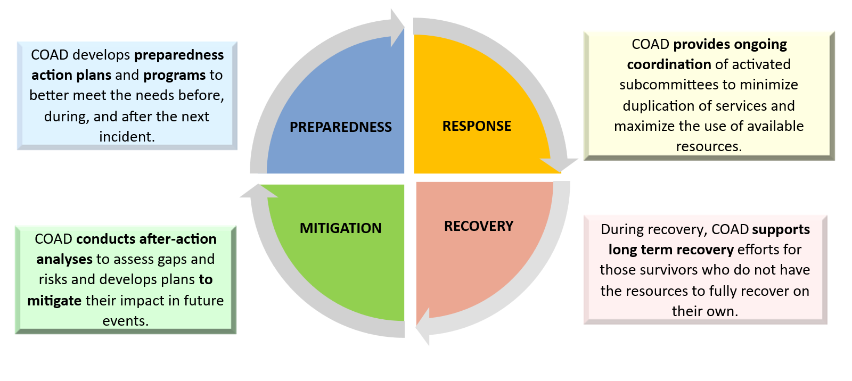
The topical area of the committee determines when they will be most active in the disaster cycle. For some committees, such as Emergency Financial Assistance (EFA), their role primarily falls during the response. While for others, such as Access & Functional Needs + Older Adults, the focus is on preparing vulnerable individuals to mitigate the impact of future disasters.
All committees require some level of mitigation and preparedness planning to be resourced and ready for the next incident. This may include ongoing preparedness campaigns, establishing protocols for response, developing tracking systems, and ensuring supplies are available.
After action analyses and lessons learned are core to COAD’s mitigation work to provide critical information for preparedness to ensure more effective responses for future incidents.

COAD LEADERSHIP PRINCIPLES
When leading a COAD committee during a disaster response, it is important to remember three critical components of leadership: vision, tasks, and relationships. Vision is synonymous with purpose and knowing where you want the team to go. Tasks are the actions leaders take to be effective, such as creating purposeful agendas and ensuring resources. Relationship speaks to connections to other people and the personal insight needed to fully value these relationships. All are integral to leadership. Leaders most often work in the vision and relationship domains. Synthesizing leadership skills into the demands of the moment is what leadership is truly about.
Leadership involves managing a wide range of relationship: those who we report to, those who we manage, our peers and colleagues, and numerous outside organizations and partners. In all COAD work relationships, we strive for collaboration, respect, inclusion, and transparency as appropriate.

(Leadership model courtesy of Brett Penfil, May 2023)



Within COAD, the focus typically rests on three leadership styles: collaborative, consensus, and command and control. Each has unique features that meet the demands of the work involved to prepare for, respond to, and recover from disasters. The following chart compares these three leadership styles.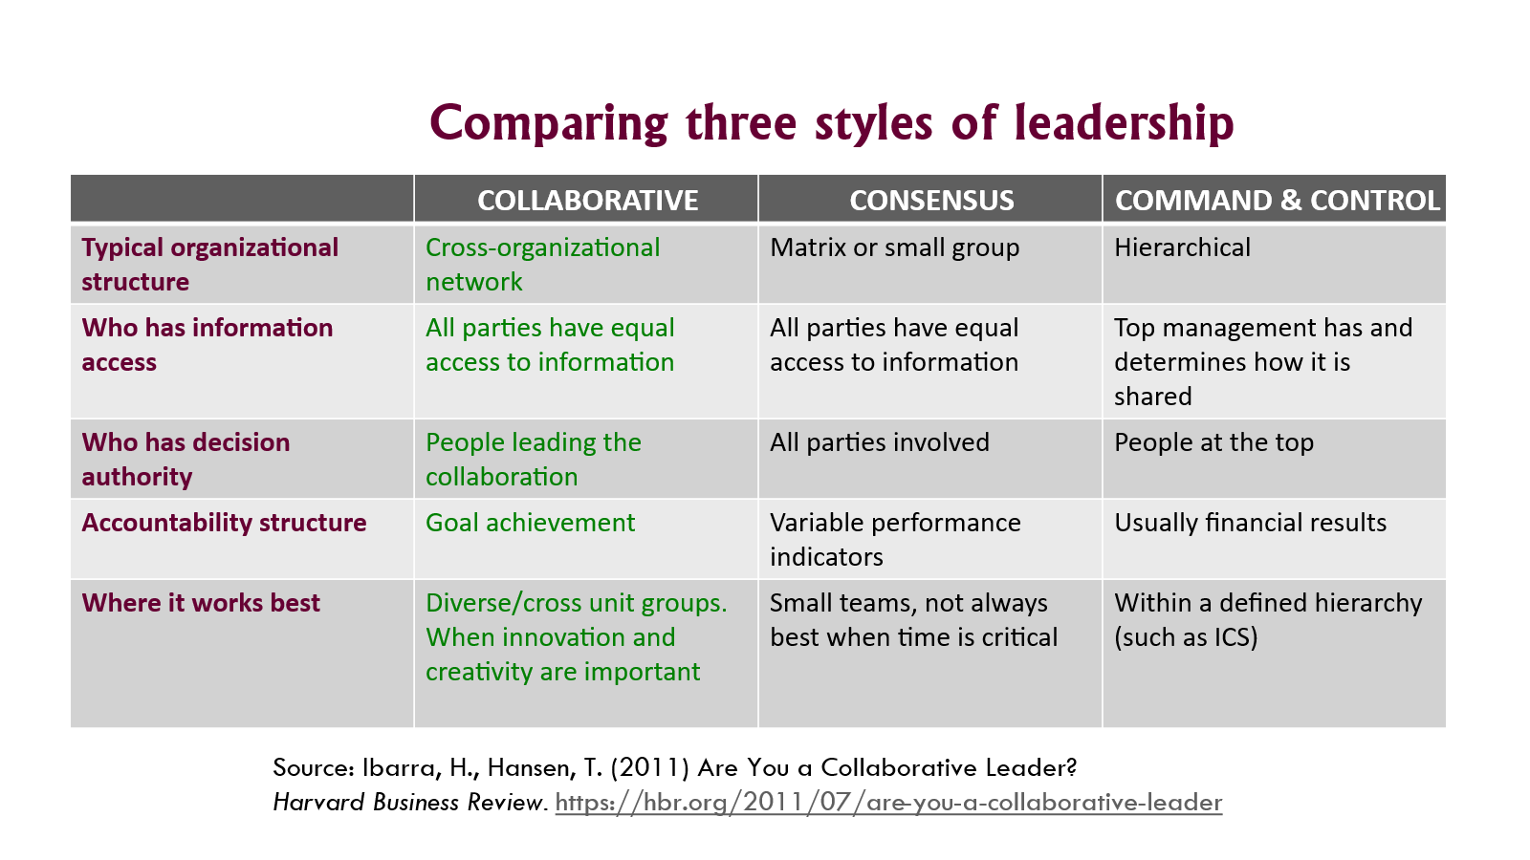
More in depth information on how COAD uses each of these leadership styles is covered in the following sections:
- Section II – COAD’s Operating Principles and Practices: COAD’s use of Incident Command Systems (ICS) during disaster response, discussed in this section takes into consideration that there may be times when a command-and-control approach is needed to ensure timely and tightly coordinated objectives are met.
- Section IV – COAD Committee Leadership & Responsibilities. Collaboration is core to COAD’s values and is discussed more below. Approaches for being a collaborative leader are explored in detail in Section IV – COAD Committee Leadership & Responsibilities.
- Section VIII – Consensus Building & Decision Making. Consistent with collaboration and inclusion is the need to share decision making and use consensus whenever possible.
Collaboration is a core value of COAD and the preferred way of operating. Collaboration is the joint actions we take to identify common goals to address the problems identified and create shared solutions. Collaborative leadership is essential when bringing individuals together who are usually outside your formal control. As a coalition of independent organizations volunteering in COAD’s coordinated efforts, we must use collaboration whenever possible. Collaboration is at the heart of COAD’s relationship with its members and committees. COAD leadership serves as the core connector among its members. Many members note that the collaboration they experience working within COAD helps build strong connections with other agencies in the work of their primary mission.
Collaborative leadership focuses on teamwork, respect for diversity of opinions, communication, and trust. To ensure innovation, collaboration needs to be inclusive. Open and shared communication is critical for collaboration to work; leaders must recognize and accept that there are many different communication styles. True collaboration engenders trust, fosters engagement, helps people take ownership of the work, and builds connections. People must feel heard and respected to take ownership of work and tasks. This becomes more important as work is shared to achieve goals collectively.

SECTION II - COAD OPERATING PRINCIPLES & PRACTICES

HOW COAD OPERATES
COAD operates according to the policies and procedures outlined in its bylaws. The COAD Executive Director leads operations, while the Board of Directors is the final decision-making authority for COAD and oversees its operations, finances, and strategic planning. COAD operates using Incident Command Systems (ICS) principles, particularly during a disaster response, but uses collaborative leadership in working with its members and within its committees for optimal results. ICS principles help COAD remain coordinated, effectively use resources to maximize their impact, limit duplication of efforts, and ensure timely, accurate communications.

OVERVIEW OF INCIDENT COMMAND SYSTEMS (ICS)
Incident Command Systems (ICS) were developed in the 1970’s to address weaknesses identified in disaster responses which included lack of accountability and unclear lines of supervision, poor communication and conflicting use of terminology, lack of orderly planning, ineffective systems for inter-agency coordination, and ‘freelancers’ taking on response activities without a leader or coordination with first responders. These weaknesses could lead to chaos in some cases, duplication of efforts, as well as potential loss of lives.
In contrast, ICS provides for unified command that promotes effective coordination and clearly defined lines of supervision and accountability. The structure makes interagency coordination and mutual aid easier because of a common structure and terminology. The improved coordination reduces duplication of efforts and incorporates ‘freelancers’ into the system. ICS principles include:
- Unified Command for events involving more than one lead agency
- Incident Command establishes a central source for authorizing everything associated with the response
- Setting Operational Objectives to guide and focus efforts
- Effective Resource Management and limiting duplication of efforts
- Limited Spans of Control to ensure staff is not overburdened and can remain effective
- Communication protocols to ensure consistent, accurate, and vetted information
- Common language, procedures, structure for coordination and ease in offering mutual aid

ICS Structure
ICS is interdisciplinary and identifies critical roles to support emergency operations. The ICS structure is organizationally flexible and can be used in different types of emergency incidents with varying complexity; it can expand or contract to meet the needs of any given incident. Within the ICS structure, SECTIONS are established with assigned areas of responsibility. Typically, each section has a CHIEF to which all staff and volunteers in that functional area report. The key sections and their functions are highlighted in the graph below. All sections work together and are integrated under the unified command of the Incident Commander (in Napa County, the EOC Manager). During the most critical incidents with broad impact, all sections are typically activated. In smaller, localized incidents with less impact, only needed sections may be activated by the Emergency Operations Center (EOC).

TYPICAL INCIDENT COMMAND SYSTEM STRUCTURE AND RESPONSIBILITES
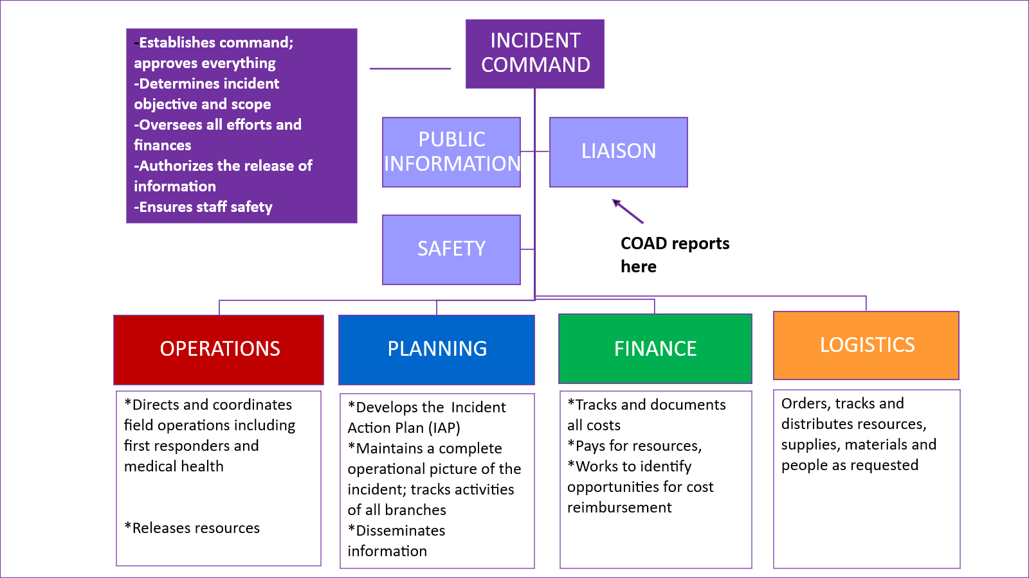

HOW COAD INTEGRATES INCIDENT COMMAND PRINCIPLES
COAD does not operate like the County’s Emergency Operation Center (EOC) which is more structured for first responders and has a much larger staff and range of operations. As second responders, COAD and its committees have more flexibility in how we operate and choose to incorporate ICS principles into our response and other operations. COAD has adopted those principles that enhance our ability to launch and maintain an effective, tightly coordinated response. These include:
- Incident Command – During a response, a clear, central lead organization responsible for overseeing the entire operation is essential to ensure effective coordination. For COAD, this is the Board of Directors and Executive Director. A unified incident command keeps everyone on the same page.
- Operating Objectives – Setting operational objectives for defined periods helps to maintain focus on areas in need of COAD support, better coordinate, clearly communicate our role, and takes into consideration our capacity to respond. COAD’s operating objectives are derived from the county objectives taking into consideration the nature and scope of the disaster, the unmet needs identified, and the unique role COAD plays in supporting areas that are outside the scope of the government’s response.
- Communication Protocols – Establishing and following communication protocols are essential to ensure only vetted and accurate information is shared. When misinformation is shared during a disaster, this causes confusion and in the worst case, can cost lives.
- Span of Operations – Each COAD committee is assigned to focus on a core topical area during a response. Creating reasonable spans of control helps to ensure that no committee or person becomes overwhelmed. If needed during a response, committees may need to split into distinct areas to ease workload. The goal is to distribute the work appropriately so everyone can remain effective.
- Closing Loops – It is crucial to follow up and ensure any requests are completed. Closing the loop involved asking: Was the request met, was the task completed, was it timely, are there any other unmet needs? When we do not close loops, we are at risk of causing confusion, duplication, or overlooking important details or tasks.
Referencing the typical ICS chart above, the following chart shows COADs roles:

COAD INCIDENT COMMAND ROLES

ICS ROLE | WHO | COAD DESCRIPTION
Incident Command | COAD Board of Directors and the Executive Director | Assess circumstance to activate COAD and are the final decision-making authority when others cannot reach a consensus.
Operations | Disaster Coordinator and COAD Committees | The Disaster Coordinator oversees the work of the COAD committees serving as the Operations section.
Plans | Disaster Coordinator | Maintains oversight of COAD’s coordinated response. Helps to set operating objectives, keeps track of and documents response activities, and facilitates communication across committees.
Communications | EOC Liaison & PIO Committee | Within COAD, the EOC Liaison (see COAD structure in Section I) serving in the County’s Emergency Operations Center, is the internal communications person for keeping COAD agencies informed. This role provides information critical for the response and amplifies County public messaging.
Logistics & Finance | Disaster Coordinator, Committee Chairs | The role of getting resources and paying for them is a shared responsibility, but primarily falls on the Disaster Coordinator. Resources may be requested from the County or the Community. Informational resources are typically provided by the Disaster Coordinator.

SECTION III – COAD ACTIVATION PROCESSES

COAD ACTIVATION PROCESS

What does it mean for COAD to be “activated?”
An “activation” means that COAD is actively engaged in a disaster response or recovery. Other phases of disaster, such as a preparedness, may also involve COAD being active, but this is different from a formal activation.

What kinds of emergencies/disasters trigger an activation?
Emergencies and disasters come in many forms and no two are alike. The most typical disasters for triggering an activation include: wildfire, flood, and earthquake. Public Health crises, such as a pandemic or an acute disease outbreak, may also trigger an activation. Additionally, power outages, such as a Public Safety Power Shutoff (PSPS) or weather-related outages, can result in the need to activate to support vulnerable populations in specified areas. COAD’s Board of Directors determines when it is appropriate to activate COAD to meet a need in the community.

What is the purpose of an activation?
During an activation, COAD’s main function is to mitigate the impact of the disaster or emergency by collaborating and coordinating services among COAD members and local emergency management/local government. The purpose of an activation is to identify and address gaps in services and to minimize any duplication of services. COAD’s focus is on ensuring the needs of the community’s most vulnerable populations are equitably addressed and met, including individuals with access and functional needs and those who have limited financial resources.

What is COAD’s role in an activation?
During a disaster, the role of the COAD is to coordinate non-profits, faith-based organizations, and private sector members in supporting the response and/or recovery from a disaster. COAD is not usually a direct service provider to the community, but directly supports agencies participating in the response. COAD members bring a myriad of resources to serve a diverse array of populations, particularly those who are most vulnerable. Local government cannot meet these needs alone and relies other direct service providers to help meet the needs of the community’s populations most at risk for devastation. As noted in Section I – COAD Structure and Leadership Principles, COAD sends a representative to the County’s Emergency Operations Center (EOC) to serve as a liaison to COAD for communication and coordination purposes. This role is vital to an effective coordinated response.

How is the COAD activated?
- When the County activates the Emergency Operation Center (EOC) and requests COAD’s presence in the EOC. The designated COAD Liaison goes to the EOC within several hours of the request.
- Through a special request from county and/or city government or other entity with which COAD has a direct association.
- COAD may self-activate based on an identified need and approval from its Board of Directors.

What happens when COAD is activated.
When the COAD Executive Director receives a request to activate, the first action is coordination with the Board of Directors. From there, assignments are made for the key roles in the response and then Committee Chairs are notified. The next step is to organize an activation meeting to inform the COAD membership. See Appendix 2 – COAD Activation Sequence for a summary of the typical activities in the first 12-24 hours of an activation for an acute situation.
Determining the scope of the response and operating objectives
COAD will develop operational objectives during an activation for defined operational periods to guide response activities and maintain operational focus. The operating objectives for the committee should be consistent with and within the scope of the committee functions and COAD’s overall objectives and mission. Objectives may be determined based on the different stages of the disaster. Documenting the operating objectives will help future subcommittee members know where to focus their efforts.
When developing operational objectives, the following questions are considered. See APPENDIX 3 – Setting Operating Objectives for more details.
- What is the scope of the government response? How can COAD complement these efforts? What are the gaps? The Incident Action Plan (IAP) produced by the Plans Section of the EOC identifies County objectives and activities for each Section and branches within the section.
- What are the community needs presented by the disaster? What are the anticipated needs?
- How many residents/households are impacted? How are they impacted? How many are estimated to be vulnerable populations? How can they be identified?
- Where are impacted populations located?
- What services have been lost, such as power or water. What other disruptions of services are occurring such as gas and roads.
- Have schools been closed?
- What are the needs at the evacuation center or shelter operations?
- Which COAD committees are best activated to meet the immediate and emerging needs of the community?
- What is the capacity of COAD, its committees, and member agencies given the disaster/emergency and its impact?
- Are the proposed incident objectives consistent with COAD’s mission, purpose, scope of work, and capacity to deliver?
- What is an appropriate time period for the operational objectives? When should they be reviewed based on anticipated events and emerging needs?

ROLES & RESPONSIBILITIES IN AN ACTIVATION

As discussed in previous sections, numerous roles need to be fulfilled during an activation. Following is a summary of these roles and key responsibilities.
- COAD Board of Directors: Provides overall leadership and maintains oversight and support of COAD disaster operations. Specific duties include:

- Appoint Incident Commander, EOC Liaison, and Disaster Coordinator
- Meet as required to activate/deactivate COAD
- Maintain oversight of COAD activation response
- Facilitate COAD meetings when Executive Director or Coordinator are not available
- Respond to any operational issues that arise in coordination with Incident Commander, EOC Liaison and Coordinator

- COAD Incident Commander: The Board of Directors Chair also serves as the “Incident Commander,” responsible for overall oversight and direction of COAD’s response. The Incident Commander has the overall authority and responsibility for management of all incident operations. Specific Duties include:

- Oversee COAD Activation
- Represent COAD with funders and local government for policy decisions
- Work with the Director to determine the committee structure and activations
- Work with EOC Liaison and Disaster Coordinator to post updates from EOC and other agencies
- Ensure a Public Information Officer for COAD if not already assigned/activated
- Seek participation from agencies not involved but that may be needed for response efforts

- COAD Disaster Coordinator: Appointed by the COAD BOD, the Disaster Coordinator is the connector between the EOC Liaison, COAD, member agencies. Oversees all components of the activations and coordinates all logistics including member communications, meetings, updating of resource guide etc. Specific duties include:

- Maintain awareness of all aspects of the activation and tracks requests, tasks, and activities. Communicate regularly with EOC Liaison
- Communicate meeting logistics with COAD membership through email, phone, text, and website.
- Organize and lead COAD response meetings and their agendas
- Ensure notes are kept for all meetings and maintain and file any meeting documentation
- Update and maintain COAD website and Facebook page during the incident

- COAD EOC Liaison: Reports to the EOC and serves as a connector between the EOC and COAD members. This is normally the COAD Executive Director or member of the Board of Directors or another COAD leader. In many cases, the EOC Liaison and Disaster Coordinate roles are fulfilled by the Executive Director, but it is important to have backup individuals and to rotate these roles. Specific Duties Include:

- Report to the EOC for designated shifts and attends all appropriate briefings
- Complete required forms as required for EOC operations
- Maintain regular communication with Disaster Coordinator and Incident Commander
- Provide briefings to COAD members on the incident, including the County’s and COAD’s response activities

- COAD Committee Co-Chairs: The role of the COAD Committee Co-Chairs it to manage the coordination of the agencies and individuals engaged in the committee’s work and to determine the best way to share the workload amongst committee members. Specific tasks include:

- Send an email/text/phone to alert Committee Members of meetings, the meeting venue, and agenda
- Hold regular meetings or communicate via email as needed to coordinate response efforts.
- Assure that committee notes are taken stored and maintained on the shared platform.
- Communicate regularly with COAD Disaster Coordinator
- Review needs presented in COAD briefings and/or from EOC Liaison
- Review activities member agencies are taking and ensure no duplication of services or gaps exist
- Share the workload and be available to support committee members. See Section VII – Sharing the Workload. Assign tasks, track tasks and report to activity to the Disaster Coordinator
- Identify training and resource needs for the committee and share needs with to the Disaster Coordinator
- Establish strong communication with committee members
- If the disaster will enter a long-term recovery phase, participate in COAD meetings to determine next-steps
- Participate in COAD’s after-action analysis by completing the questionnaire and participating in any scheduled after-action meetings

- COAD Member Agencies: Join committees according to the resources typically provided to the community before, during, and, after a disaster. They will coordinate with other agencies and through committees to ensure that there are no duplications and/or gaps in services provided to the community. Each member agency is asked to update the Resource Directory at the beginning of an activation and whenever there is a change in status. Specific duties include:

- Regularly participate in COAD general meetings, briefings
- Identify agency core role and any enhanced roles assumed for the disaster or emergency.
- Join a COAD Committee if capacity permits that pertains to agencies works or skills
- Regularly participate in COAD Committee meetings and/or activities
- Work within the framework of COAD’s operational objectives, protocols, and missions.
- Update the COAD Resource Directory at the beginning of an activation and when there is a change in status. Keep COAD informed of the organization’s disaster and preparedness related activities to ensure coordinated efforts
- Regularly visit COAD Facebook & Instagram page and website for important information and updates

COMMUNICATION PROTOCOLS & FLOW DURING A DISASTER

All vetted communication flows to COAD through the County Emergency Operation Center (EOC) and Public Information Officer (PIO). This ensures vetted, timely information. The EOC is in constant contact with first responders who are providing real-time information. The EOC PIO communicates directly with the public and provides the essential information to keep them safe. COAD amplifies these communications, especially to vulnerable populations, through its member agencies and social media networks.
COAD primarily receives its information from the EOC/PIO through its Liaison role in the EOC. This is typically more detailed information to facilitate COAD creating an effective coordinated response among all agencies which complements the role of the County. Agencies should not expect to receive additional communication directly from the County; it is COAD’s role to be the conduit of critical information to member agencies. The graphic below outlines the flow of communications.

COMMUNICATIONS FLOW DURING DISASTERS
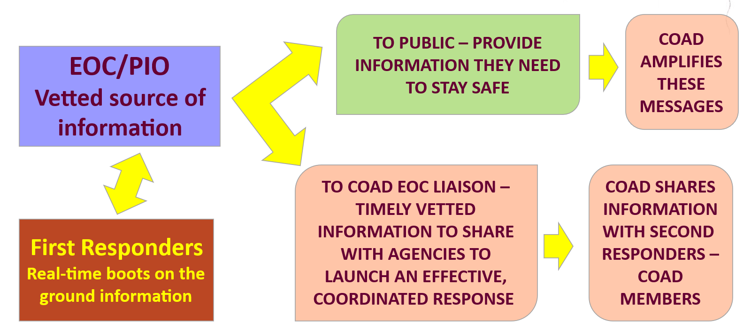

COAD COMMITTEE ADVISORY COUNCIL

At the beginning of each disaster response, a group of seasoned COAD leaders with experience in disaster response and committee leadership will be announced by the Executive Director. These individuals, along with the Executive Director, will be available to assist committees by providing expertise and navigating a wide range of issues during an emergency including:
- Organizing a committee and getting started
- Obtaining physical and information resources
- Making decisions to move forward with solutions
- Coordinating with other COAD committees and organizations outside of COAD
- Dealing with obstacles in getting information or resources
- Addressing the demands and stresses of working with disaster survivors
COAD will also arrange for Committee Leader check-in meetings to support needs, coordination, and the flow of information. More information on these meetings is provided in Section IV – COAD Committee Leadership.

SECTION IV – COMMITTEE LEADERSHIP & RESPONSIBILITIES

BEING A COLLABORATIVE LEADER

Despite the use of Incident Command principles to ensure an effective and coordinated response, collaboration is at the heart of COAD’s relationship with its members and within committees. As a coalition of independent organizations volunteering in COAD’s coordinated efforts, it is imperative that we employ collaboration whenever possible.
What does it mean to work collaboratively within COAD
Collaboration is a core value of COAD and our preferred way of operating. Collaboration is the joint actions we take to identify common goals to address the problems identified and create shared solutions. Collaborative leadership is essential when bringing together individuals who are generally outside your formal control. Collaborative leadership is inclusive and consistent with COAD’s values.
Two core skills in collaborative leadership are effective facilitation of meetings (see Section VI- COAD Committee Meetings – Facilitating Effective Meetings) and sharing the workload (see Section VII – Sharing the Workload). A collaborative leader is often a facilitator during meetings and ensures that input from everyone is considered. When Information is shared transparently and all have the opportunity for input, it promotes group engagement and sharing responsibility for the work and outcomes.
Being a collaborative leader
Collaborative leadership focuses on teamwork, respect for diversity of opinions, communication, and trust. To ensure innovation, collaboration must be inclusive. Open and shared communication is critical for collaboration to work, and leaders must recognize and accept that there are many different communication styles. True collaboration engenders trust, fosters engagement, helps people take ownership of the work, and builds connections. People need to feel heard and respected to take ownership. Collaborative leadership also reduces the potential for conflict by employing active listening and inclusion.
Actions that promote being a collaborative leader include:
- Active listening is the place to start. This requires focusing on what is being said and reflecting on it by clarifying and confirming with the speaker. For example, “I hear you recommending…. Is that correct?” Do not interrupt the speaker. Instead, provide the time for them to complete their thoughts. Ask others to share their thoughts as well.

- Build mutual trust within the work group. This can be done by ensuring open, transparent communication, seeking input, and engaging everyone in the work and problem solving.

- Communicate regularly and be transparent about communications. Keep information flowing across activities. Keep people informed about the work of the committee and avoid silos and micromanaging. Open communication is essential to collaborative and effective leadership during an emergency.

- Create space for all to participate, engage and feel valued in meetings. This starts with building an agenda structured to provide time for input and focus on objectives. Not everyone feels comfortable sharing in groups, either online or in-person. It is always good to ask if anyone else has something to share before wrapping up a discussion; it is even alright to ask if anyone who has yet to share would like to do so before moving on. Provide plenty of opportunities for input and explore creative ways to be inclusive without calling people out. If you would like to try other strategies for inclusion, below are some to consider in different forums. Be careful not to get too complicated.

  - Online strategies – Asking people to add their thoughts to the chat functions on online platforms is sometimes the easiest for people not comfortable speaking to share their input. Additionally, Padlet or similar apps provide the opportunity for groups to share thoughts anonymously via electronic notes to a common message board. You can sign up for a free Padlet account which includes three Padlet boards at https://padlet.com/auth/signup. Your agency may already have some online applications to help create more interactive, inclusive meetings.
  - In-person strategies – Using the same approach as above, ask everyone to share their thoughts on a sticky note or piece of paper, then share and organize the ideas on a visible board.
  - Break out groups or rooms are also good strategies for providing less intimidating spaces for some individuals to share.

- Share the workload. This topic is discussed more in Section VII – Sharing the Workload. COAD Committee Leaders must be willing to share the workload or, it can become too much for one or two people to carry the committee’s work. Asking for committee members to take on tasks communicates trust and encourages engagement and ownership of the work. Be clear about instructions for tasks with clear deadlines. Check in to see if help is needed to get the task accomplished.

- Promote team work. Be a connector and help build relationships among committee members. Encourage people to team up and work together on tasks so that a backup is always in place.

- Build consensus when possible and if time permits, this supports greater engagement in problem solving and shared solutions. When building consensus, everyone needs to express where they stand. Section VIII - Consensus Building & Decision Making provides a more in-depth discussion on building consensus.

- Provide opportunities for sharing frustrations. Disaster response is demanding, and people can periodically feel frustrated and overwhelmed by the tasks and obstacles. As leaders, we must be nimble and flexible to navigate obstacles and frustrations. Sometimes this requires that we first share frustrations. This can provide an opportunity for problem solving. It is important to show empathy when people share frustrations, but then to lead everyone back to work.

LEADING DURING TIMES OF CRISIS

First, stay calm and breathe. Seriously, take a minute to slow down and focus on your breathing periodically. Remember, in COAD we are not first responders dealing directly with life-threatening situations. We can take a moment to be thoughtful and intentional. We do not want to react but instead respond with sound plans in an organized and coordinated manner.
A benefit of Incident Command principles is that they provide a structure for a response by identifying operating objectives and defined roles. When requests become overwhelming, the roles and objectives defined by the operating objectives serve as a centering point and a tool for prioritization. Questions to stop and consider during an activation:
- Is the request within the scope of the committee’s and COAD’s current objectives?
- Does the committee have the necessary capacity?
- Who would be best suited to respond to the request?
- Should I check with the advisory council or Disaster Coordinator on the request?
Remember, there are support systems and people to turn to within COAD when you need assistance. Use them!
Addressing conflict and intense emotions
During times of high stress, it is not uncommon for emotions to rise and potential conflicts to develop, even when working collaboratively. When these situations occur, consider the following:
- Avoid a confrontational response to the conflict, which feeds into the emotions or conflict. Work to remain calm. Ask everyone to stop and lead a one-minute breathing break – provide a count for breathing in and out.
- Give the person(s) time to express their concerns and ask them to be specific. Ask questions such as, ‘Help me to better understand your concerns.’
- Suggest a break for the group and talk privately with the person – even if online.
- Have everyone take a breath, stop, and reset the meeting. Maintain facilitative control of the meeting discussed more in Section VI – COAD Committee Meetings.
- Be open and acknowledge that disagreements are part of the process – not everyone can always agree. The goal is to manage the discussions around airing differences.

COAD COMMITTEE SPAN & SCOPE OF CO-CHAIR RESPONSIBILITIES
COAD focuses committee work in the core topical areas typically needed in response. As a result, COAD identified nine response committees. See APPENDIX 1 – COAD Committee Roles During Each Phase of Disaster for a full description of COAD’s response and preparedness committees and their typical activities. During a prolonged or complicated response, splitting committee responsibilities may be necessary as not to overburden any individual committee. If your committee feels that it cannot meet the objectives or is stretched beyond capacity, please reach out to the Disaster Coordinator immediately.
COAD Committee Co-Chair Role Description
A Committee Co-Chair’s role is to manage the coordination of the agencies and individuals engaged in the committee’s work and to determine the best way to share the workload, between the Co-Chairs and the committee members. A key goal is to get committee members to engage and take ownership of their work. More information about getting started with your committee and facilitating meetings to promote engagement is covered in Sections IV and VI, respectively.

Specific tasks include:
- Send an email/text/phone to alert Committee Members of meetings, the meeting venue, and agenda.
- Establish strong communication with committee members. Hold regular meetings or communicate via email as needed to coordinate response efforts.
- Assure that committee notes are taken stored and maintained on the shared platform. See Section IX - Tracking & Storing Your Committee Work.
- Communicate regularly with COAD Disaster Coordinator.
- Review needs presented in COAD briefings and/or from EOC Liaison.
- Review the activities member agencies are taking to help ensure no duplication of services or gaps exist.
- Share the workload and be available to support committee members. See Section VII – Sharing the Workload. Assign tasks, track tasks and report committee activity to the Disaster Coordinator.
- Identify training and resource needs for the committee and share needs with the Disaster Coordinator.
- If the disaster will enter a long-term recovery phase, participate in COAD meetings to determine next-steps.
- Participate in COAD’s after-action analysis by completing the questionnaire and participating in any scheduled after-action meetings.

Subcommittee leader time commitment
The time commitment for COAD Committee Leadership varies based on the type of disaster, the level of response, and the committee role. Here are some general guidelines to consider. Remember, the COAD leadership role is in addition to the response work of your agency.
- During the first weeks of a response, committee leaders will spend a few hours a day attending to committee coordination and meetings and COAD briefings.
- During an acute response, such as a fire or earthquake, the response and early recovery may last several months. After the first few weeks of the response, committee leadership responsibilities will likely drop to several hours per week.

- During a prolonged response, such as a pandemic, the time commitment will likely move to meetings every 2-4 weeks, with leadership responsibilities taking up to a few hours per week.

- During non-disaster times, COAD Committee Leaders may take a break from their leadership role and convening meetings. COAD will initiate committee meetings periodically to facilitate reconnecting and reviewing preparedness for potential events.

Connecting with other COAD committees and community groups

The Committee Leader check-in meetings are forums for sharing, connecting, and ensuring work across committees remains connected. The Disaster Coordinator and Executive Director will facilitate connections within and outside of COAD. If a committee needs to connect to an outside group, they can do so independently but must inform the Disaster Coordinator. If assistance is needed with making a connection, the Disaster Coordinator or Advisory Council can support as noted in Section III – COAD Activation Processes.

COAD COMMITTEE LEADER CHECK-IN MEETINGS

Depending on the nature of the disaster and the pace of change involved in the response, the Disaster Coordinator or COAD Executive Director will schedule regular update meetings for Committee Leaders. Initially, these meetings could be daily and then shift to every other day, weekly, monthly, or twice a year (during blue sky times). These meetings provide the opportunity to connect with other committees around needs, resources, and avoiding any duplication of efforts. At these meetings, leaders are asked to report on the following (see Appendix 4 -COAD Committee Co-Chair Meetings for a sample agenda of what is covered during check-ins).
- COAD Disaster Coordinator will provide a situation status update
- Review of operating objectives for COAD – Identify any updates needed
- Committee reports on current activities and relevant stats; current unmet needs, anticipated emerging needs, and coordination needs
- Summary needs analysis and coordination planning. Identify needs to be elevated to the Emergency Operations Center
- Review of resulting action items, responsible parties, and deadlines.
- Schedule the next meeting based on an assessment of needs.

AFTER-ACTION REPORTING
After Action analyses are core to COAD’s operations to ensure that lessons learned are documented and incorporated into mitigation and preparedness planning for future responses. Once response work is coming to an end, COAD will ask Committee Leaders to work with their committee to conduct an after-action analysis. A template for the after-action analysis is available in APPENDIX 5 – AFTER-ACTION TEMPLATE. A copy of the template can also be found on the shared Dropbox platform.
Following is the list of questions typically explored in an after-action analysis:
- What agencies were involved with your committee and what services did they provide for COAD’s coordinated response?
- What were the key functions and activities of your committee during the response?
- What were your committee’s key accomplishments? What went well? What went as anticipated or according to plan?
- What obstacles or issues did your committee experience?
- Share your committee’s experience around coordination and collaboration within and outside of your committee?
- What was your experience staffing your committee? Were you able to get enough engagement to support committee work? Were members able to take on responsibilities?
- Is there anything that could have supported more committee member participation?
- What were the lessons learned? What were your committee do differently in the future?
- How can COAD better support the work of your committee?
- What recommendations does the committee have for future events?
Calculate the time commitment of your committee, be sure to include meeting time and an estimate of the time spent by all committee members on coordinated COAD response activities

SECTION V – COAD COMMITTEES: GETTING STARTED

This section is designed to help you get started with your COAD committee – what needs to get done first, who to contact, who to recruit, and where to get help? The information in this section, combined with other sections on facilitating meetings, sharing the workload, and building consensus, are designed to assist leaders in setting the foundation for their committee to work collaboratively.

RECRUITING COAD COMMITTEE MEMBERS

Agencies associated with the committee’s topical area
Agencies associated with the committee’s topical area typically provide a service related to the committee’s work and would help provide resources, referrals, materials, or anything needed to accomplish the objectives established by the committee. For example, the Food Access committee is mainly comprised of food providers; Mental & Spiritual Health is comprised of mental, spiritual, and behavioral health providers from a wide range of agencies; while family resource centers may have representatives on multiple committees because of the wide range of services they provide within the community.
Focusing on the agency’s specific services helps to ensure the right people are at the table to support the committee's work. See APPENDIX 8 – COAD Resource Guide for a list of COAD member agencies and their primary functions and services. The Executive Director and Advisory Council are resources for assisting with committee recruitment.
Being inclusive and welcoming
COAD values collaboration and cooperation, equity and inclusion, cultural sensitivity, dignity and respect for each person’s experience, and meaningful engagement with partners and the community. Committees must create a welcoming and inclusive environment for their members to create the best conditions for collaboration, which fosters better community engagement and support. Tips for being a collaborative leader can be found in Section IV- COAD Committee Leadership & Responsibilities.
Identifying and inviting individuals with lived experience
Inviting individuals with lived experience into your committee allows the perspective of community members, in and around disasters, to be heard and share their valuable experiences. This allows a better understanding of what survivors go through when facing emergencies and helps the committee consider these hardships when creating or reviewing shared solutions. Lived experience is valuable in COAD’s work during all phases of disaster. It is important to always be sensitive to what people have gone through. Always ask permission to share their stories and do not assume that they are willing to share just because they have joined the committee. These individuals may work with COAD member agencies or may be community members unassociated with any agency. COAD will work to assist in identifying community members with lived experience who are interested in participating in our work.
Gaining engagement through understanding and shared responsibility
It is important to remember that committee members typically have fulltime commitments outside of their participation in COAD and may not always be available. Therefore, sharing the workload and responsibilities of the committee promotes a more balanced workflow and task completion. COAD Committees work as a team and must share responsibility for the goals and action items of the committee. Leaders must share the workload beyond those they know to ensure inclusivity. When the workload is shared, committee members are more invested. See Section VII – Sharing the Workload for more tips on balancing committee workloads.

GETTING STARTED WITH YOUR COAD COMMITTEE

First actions to take
When meeting for the first time, everyone should introduce themselves and share their contact information. This ensures that everyone remains in communication in and outside of an emergency response. The Co-Chairs of the committee should then direct everyone’s attention to the goals and objectives of the committee for an effective meeting that makes good use of everyone’s time.
COAD operations overview
Committee members need to know and understand how COAD operates and communicates during all phases of disaster. This overview should include information from Sections I, II and III of this Guide. The Disaster Coordinator can assist in providing this information. In the future, COAD will have a short video to cover this information.
Understanding the Committee’s Role and Function
It is important to know the role and function of the committee when establishing operating objectives. The role and function of each committee can be found in APPENDIX 1 – COAD Committee Roles during all Phases of Disaster which outlines typical activities of each committee.
Sharing contact information
Members of the committee will be working closely together for the foreseeable future and, therefore, must be able to communicate easily with one another when needed. The Co-Chairs will have a distribution list handy for mass communication via email and/or text during and outside of a response. Committee members may also need to share materials and resources outside of these communications. Members of the committee should share their name, organization, phone number (cell is preferred), and email with everyone for easy reference.

Setting operating objectives based on COAD’s overarching operating objectives
Committees develop operational objectives to guide activities and maintain operational focus, while staying within the scope of COAD’s mission and values. When developing operational objectives take the following into consideration:
    - What objectives has COAD defined for the overall response?
    - What is the scope of the Subcommittee? What are the community unmet needs which this committee can address?
    - What resources can the committee provide through agencies on the committee?
    - Are the proposed objectives consistent with COAD’s mission and scope of work?
    - Where are impacted populations located? How many residents/households are impacted? How are they impacted?
    - What is an appropriate time period for the operational objectives? When do you anticipate changes will occur?
    - What services have been lost or impacted? Are schools closed?
APPENDIX 3 – Setting Operating Objectives provides a more in-depth discussion around operating objectives.
Setting the meeting schedule
The meeting schedule is determined by immediate and anticipated needs. See Section VI– COAD COMMITTEE MEETINGS – Facilitating Effective Meetings for a deeper discussion on scheduling and running committee meetings.

COMMUNICATION AND MEETING TEMPLATES
To assist subcommittee leaders in setting agendas, templates have been developed to identify the key topics that are typically covered in meetings. See APPENDIX 5 – COAD Committee Agenda Template for an overview of how to structure committee meetings, as well as when and why to meet.
Communications within and outside the committee may include, but are not limited to: online meetings via Zoom, Google Meet, or Teams; in-person meetings; email; and Text/Phone call. The Co-Chairs can decide the best mode of communication based on needs to be addressed and committee member schedules.

SECTION VI – COAD COMMITTEE MEETINGS: FACILITATING EFFECTIVE MEETINGS

WHEN AND WHY TO MEET

Committee meeting frequency
COAD committees are not required to meet at any specific frequency; it depends on the nature of the disaster and work. COAD does request that committees stay connected and share information via whatever means is appropriate which could be email or text, as well as meetings.
The first few meetings, either online or in-person, are critical as the committee members will get to know each other, learn about the functions of the committee and their specific roles, and set a direction for the work of the committee. Meetings are essential for sharing ideas and problem-solving.
At the beginning of a response, in that first couple of weeks, meetings may be daily or every other day to help establish connections and identify the work and direction of the committee. After that, the committee can determine a meeting schedule that allows members to stay connected, meet required needs, and maintain situational awareness of emerging needs.

When to meet – things to consider
At the beginning of a response everyone will be busy therefore virtual meetings via online platforms such as Zoom, Google Meet, or Teams are preferred, but in-person meetings may also be necessary. In-person meetings help people get to know each other and, develop working relationships, and can promote inclusivity in a more personal way. There are also specific reasons for meeting.
- A meeting is essential to initially getting connected and identifying roles and committee objectives.
MEETING FUNDAMENTALS
- Meet for the right reasons
- Invite the right people
- Agree to ground rules on how the meetings will work
- Have a facilitator
- Have a purposeful agenda
- Record your work
- Start and end on time
- Evaluate your meeting

- Meetings need to be scheduled when two-way communication is needed for sharing ideas, exploring options and problem solving.
- Meetings need to have identified objectives and each agenda items should have a purpose. Consider what needs to be to accomplished as a group? Can it be accomplished via email or does it require discussion or a decision to be made?
- Is there a problem that needs to be solved which requires input and discussion? Is there a need to clarify and address questions that require discussion?
- Is there group training required to make the committee more effective in its work?

When email might be sufficient – guidelines for using email
If there is just one-way information sharing or simple requests, an email may be sufficient. Email is good for updates and getting quick responses and is appropriate to use when a dialogue is not necessary.
First committee meeting – See SECTION V – COAD COMMITTEES – GETTING STARTED
THE FACILIATOR’S ROLE
MANAGE TIME
Start and end the meeting on time, hold to the agenda, determine when it is appropriate to spend more time on a topic than planned.
MANAGE THE AGENDA
Have a purpose for each agenda item, ensure all topics are addressed, and if not, identify when it will be addressed later. Hold the agenda to ensure meeting objectives are met.
MANAGE THE CONVERSATION
Create opportunities for everyone to participate and ensure interaction is constructive. See ideas for creating space for to participate below.
Adopted from Brett Penfil ‘Facilitating Effective Meetings’ May 2023

FACILITATING EFFECTIVE MEETINGS

Facilitative leadership in meetings encourages participation and allows everyone to share their perspectives. Committee meetings are the forums for discussions around the committee’s work, sharing the workload, and building consensus around decisions. Many of the strategies for being a collaborative leader are also helpful when facilitating meetings including, being an active listener, creating space for all to participate, communicating openly, sharing the workload, and working toward consensus. Review Section IV – COAD Committee Leadership & Responsibilities under Being a collaborative leader for more in-depth discussion of these strategies.

Committee meeting facilitation tips
Meetings provide the opportunity and time for a committee to make progress on its assigned response areas. Keys to facilitating successful meetings include being prepared with the following: ground rules and time management, established meeting objective and a clear agenda, and active listening techniques to facilitate the discussion.

- Agree to ground rules - Set and share ground rules so everyone understands how the meeting will be conducted and has the opportunity to participate. At the initial committee meeting, leaders can ask the group if there are additional ground rules that would be helpful. Making space for everyone to contribute is an important part of the ground rules. In general, the following are standard ground rules:

  - Be present and attentive in the meeting – put phones on silent
  - Be an active listener, hear what others are saying, do not talk over someone
  - Provide the opportunity for everyone to share their perspective
  - Refrain from side conversations so everyone can focus on the meeting and avoid outside distractions
  - Be on time, we understand there are times it might be impossible due to competing demands and meetings

- Start with check ins – During disaster activations, people are operating under a lot of stress. Before diving into the main part of the agenda, a check-in at the start of the meeting may give people the opportunity to share what is happening with them personally or professionally. The opportunity to share may allow members to then focus more on the objectives of the meeting. A check-in should include specific instructions on what to share so the time can be managed and the agenda can remain on track. In addition to name and agency, some examples for check ins include:

  - A simple, let us know how you are doing in three to four sentences
  - Share a high and low from your day
  - Tell us what are you looking forward to later today or sometime soon

- Meeting agenda and objectives - Have an agenda with clear objectives identifying what will be accomplished in the meeting. The agenda should include the topics to be covered and how they will be covered, the time allotted to the topic, and who will present the topic. Work to create an interactive agenda that includes opportunities for discussion and input not just reporting out which can be accomplished through email. Send an agenda in advance so that members know what to expect and can come prepared. Pose questions to help engage and explore options. See APPENDIX 5 – COAD Committee Agenda Template for a guide to develop the agenda.
PURPOSEFUL AGENDAS
What is the purpose to each topic in the agenda:
- Inform
- Get input
- Get buy-in
- Brainstorm
- Develop
- Decide

- Managing time – hold to the agenda – The leader’s preparation includes preparing a well thought out agenda that will help achieve the meeting objectives. Discussion is important but should be focused on the specific meeting objectives. If another important topic comes up, decide to talk about it at another time and keep to the agenda at hand. When topics get off track, pull the group back to the set agenda. If the group agrees that a new item is critical to cover in the meeting, jointly review the agenda and make the necessary adjustments.

- Facilitate the discussion – Initially, remain neutral to ideas being shared to give the group room to explore, but be willing to step in and express your thoughts at the appropriate time. Discussions may include an assessment of obstacles, but work to focus on the future – what needs to be done? Avoid rehashing history too much unless it provides helpful insights for future actions. Promote constructive discussion: Ask questions like ‘how does this help us move forward?’ Be comfortable with competing ideas, challenging assumptions, and expanding the pool of ideas. Silence is ok; it gives people time to think. Help stimulate creative thinking through structured brainstorming and other idea-generation processes.

- Create space for all to participate, engage and feel valued in meetings. This starts with building an agenda structured to provide time for input and focus on objectives. Not everyone feels comfortable sharing in groups, either online or in-person. It is always good to ask if anyone else has something to share before wrapping up a discussion; it is even alright to ask if anyone who has yet to share would like to do so before moving on. Provide plenty of opportunities for input and explore creative ways to be inclusive without calling people out.

  - Online strategies – Offering people to provide input via the chat functions on online platforms sometimes is effective in making it easier for some to participate. Additionally, Padlet or similar apps provide the opportunity for groups to share thoughts anonymously via electronic notes to a common message board. You can sign up for a free Padlet account which includes three Padlet boards at https://padlet.com/auth/signup. Your agency may already have some online applications to help create more interactive, inclusive meetings.

  - In-person strategies – Using the same approach as above, ask everyone to share their thoughts on a sticky note or piece of paper, then share and organize the ideas on a visible board.

  - Break out groups or rooms are also good strategies for providing a less intimidating spaces for some individuals to share.

  - Encourage and generate participative discussion in groups by building on ideas rather than shoot them down.

- Encourage active listening in the group – you may uncover new ideas. Active listening involves paraphrasing, summarizing, reflecting, and questioning what you heard someone say. This reflecting back can help the group uncover keys to the solutions they are working to develop.

- Meeting Wrap-up – At the end of a meeting, always check in with the group to see if the objectives were accomplished and if there any outstanding issues. Go over next steps and who has ownership of those steps and their timelines. Be sure to review and share the notes as soon as possible after the meeting so there is clear documentation of follow-up action items. This is part of closing the loop that we incorporate from incident command principles. See Section II – COAD Operating Principles and Practices for more information.

SECTION VII – SHARING THE WORKLOAD

Sharing the workload among volunteers can be challenging. In COAD’s coalition, everyone is essentially a volunteer with an equally demanding role within their agency. Additionally, each organization has its own continuing operations needs during a disaster. Agencies must consider their capacity and role in the overall response when approving staff to volunteer in COAD-coordinated response activities. Everyone needs to understand expectations and required capacities upfront so that COAD resources are not over committed. No one can hold it all within a committee, and responsibilities need to be shared. Sharing the workload is important to engaging committee members and not overburdening any one person or agency.

STRATEGIES FOR SUCCESSFULLY SHARING THE WORKLOAD

For committee leaders, sharing the workload means letting go of some control. This can be hard to do with a new group of people, especially volunteers where the trust and knowledge of their work is not established. In an emergency, we are constantly delegating for results. The work needs to get done to support an effective response. Letting go is difficult because there is an inherent risk that if the work does not get done, it could adversely impact COAD’s ability to support vulnerable populations. We all can succumb to the mindset – it is easier to do it myself. However, this can quickly lead to burnout, especially during emergencies when the demands do not let up.
The first step to sharing the workload is understanding what needs to be done and breaking that down into clearly defined tasks. This happens as the committee works to define its role and identify joint solutions to meet community needs. Tasks need to come with instructions, timelines, and expectations. Everyone needs to understand the value of work and how it will support the collective efforts of the committee and COAD’s response overall.
Next, getting to know your team, including their skills and interests, is essential so the right tasks can be matched to the right people. There needs to be opportunities for questions and access to information and resources. Solid two-way communication is essential when sharing the workload. Sharing the workload can be a boon for all committee members if done well. However, if done poorly, it can create frustration and erode trust. Sharing the workload promotes trust and builds the skill base for future events and leaders. As described in Section IV, being a collaborative leader provides a solid foundation for effectively sharing the workload.

STRATEGIES FOR SHARING THE WORKLOAD WITH VOLUNTEERS

- Get to know your team and ask about skills and interests in your first meeting. The key to success is to match the right task with the right person in the right circumstance. Play to people’s strengths. Sometimes we find within incident command that the best fit is based on the person’s core competencies, not necessarily their knowledge base. For example, if you need a good organizer or planner for a task, or someone to do a spreadsheet, ask who likes that kind of work.
- When sharing the workload remember: 1) it may not get done as quickly as you would have done it; 2) the person may not have your level of experience so may need extra instructions, time and support; and 3) to focus on getting the targeted results, not on how the person does the work.
- Make sure the team knows how COAD operates and the parameters for the task at hand.
STEPS IN THE DELEGATION PROCESS
- Assignments should include an understanding of why the work needs to be done and how it fits into the overall picture, a description of outcomes, possible resources to assist in completing the task, and the timeline. Ask in advance what the committee needs to be successful. Utilize the Disaster Coordinator to help gain access to the resources and tools needed.
- Plan for check-ins in advance to ensure the work is getting done and to see if any support is needed.
- Express appreciation! In meetings use group acknowledgements at the end of a meeting so the group can express appreciation to each other and acknowledge the work that was done.

A DEVELOPMENTAL MODEL FOR ASSESSING ABILITIES WHEN DELEGATING

If we look at delegating work and sharing the workload through a leadership and developmental lens, we can identify four developmental phases in the delegation process: directing, coaching, supporting, and finally delegating. Each phase is associated with progressively higher degrees of ability and independence for the person performing the work, which coinciding with decreasing levels of leadership involvement. This model is particularly helpful when training new employees and volunteers to help them develop competence and independence in their work. Depending on the complexity of the work, the process could take hours or months.

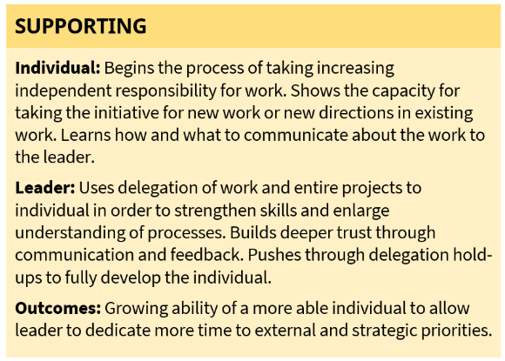
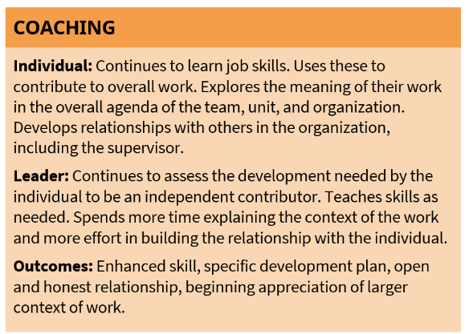
DEVELOPMENTAL MODEL FOR DELEGATION
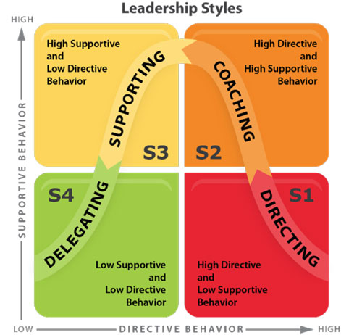

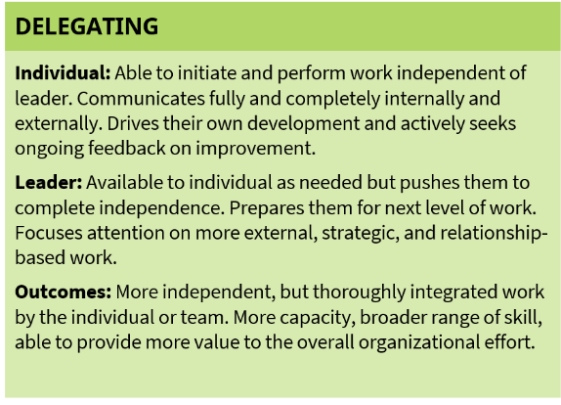
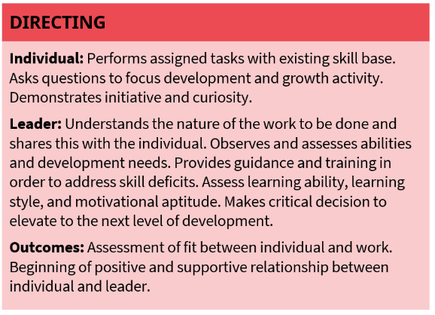
Adopted from Brett Penfil presentation to COAD - ‘Sharing the Workload’ in May 2023

In some cases, because of time constraints or the immediacy of needs in a disaster response, sharing the workload and delegating may require more of a situational leadership approach rather than a developmental approach. In these cases, the committee leader may want to be more directive or supportive to ensure the work is accomplished. The critical factors to consider are level of development, time available for the work, and risk associated with completing the work. Having contingency and back up plans is always a good strategy, as is assigning people to work together.

IDENTIFYING AND ASSIGNING ROLES

Standard roles needed in most COAD committees
- Co-Chairs usually set the agenda with input from others (see Section IV – COAD Committee Meetings for tips on agenda setting).
- Communicator who sends out agendas and other information
- Note Takers and keepers of data
- Liaison to the Disaster Coordinator
Specific roles that may be needed in some committees or for special activities
- Liaison with other committees
- Liaison with outside organizations who can support the committee
- Research information to support work, getting expert support (For example during COVID, the Emergency Financial Assistance Committee brought in experts on evictions)
Contingency and backup plans
Things happen during an emergency. A committee member may suddenly find out that they need to evacuate their own home or someone has fallen ill. That is why it always best to assign work in teams of two. We have Co-Chairs so that all the responsibilities do not fall on one person and an immediate back up is always in place.

SECTION VIII – DECISION MAKING AND CONSENSUS BUILDING
Transparency
Collaboration

DECISIONS WITHIN THE PURVIEW OF SUBCOMMITTEES

While COAD committees have latitude in determining how they will address the community needs in their topical area, they must stay within the boundaries of COAD’s mission, values, operating objectives, and practices. Any work outside these boundaries is no longer part of a COAD-coordinated response. COAD agencies are independent entities and will pursue their own work related to their individual missions regardless of their work with COAD. However, work conducted under the coordinated COAD efforts and banner must remain within COAD guidelines. As noted in the Member Charter, COAD members are asked to keep COAD informed of all response activities to ensure an effective and coordinated response and to avoid duplication of efforts. Please note:
- Public communications carrying the COAD logo or name, need to be reviewed by the Disaster Coordinator or COAD Executive Director
- NO fundraising activities may be initiated under the COAD name
- Committee operating objectives need to remain within the boundaries of COAD’s overall operational objectives unless discussed with the Executive Director and COAD BOD
- When in doubt, ask the Executive Director, Disaster Coordinator or the Advisory Group identified in Section III – COAD Activation Processes.

TYPE OF DECISIONS
For purposes of this guide, we will explore five decision types which are outlined in the chart below. They develop from the least to the most participatory and inclusive. Each has its role depending on the circumstances at hand and the leaders need to move forward with a decision. How a decision is communicated is as important as how it is made; be transparent about the process. (Adopted from Brett Penfil presentation ‘Consensus and Decision Making’, May 2023)
Decision type | How and why it’s used | Things to consider
Autocratic | - Time pressure to decide quickly  - Decision is straightforward | Can negatively impact trust
Consultative | - Need input from others, but final decision is retained by leader  - Be sure to consult those impacted | Be clear about who has final decision authority
Delegated | - Delegation can be to make a recommendation and consult with the leader, or  - Delegation to make the decision and act on it | Avoid fake delegation; it must be real or it will erode trust
Democratic | - Majority rules by everyone having a vote  - Often perceived as fair and equal, but not always equitable | May disregard minority perspectives resulting in less commitment
Consensus | - Agreement that the decision is acceptable and all can live with it | May be difficult and time consuming to work through

CONSENSUS BUILDING

Consensus building is consistent with COAD’s core values focusing on inclusion, considering all input, and building community. If consensus and decision cannot be reached, the COAD Executive Director and Board members have the final authority. Because time may be a critical factor during emergencies, using meetings effectively to reach decisions on for committee action is critical. Meeting facilitation skills, especially active listening and making space for all to contribute, as discussed in Section VI – Facilitating Effective COAD Committee Meetings will help facilitate consensus-building strategies.
Consensus building does not rely on voting to reach a joint decision. Voting may disregard the critical perspectives of individuals who fall into the minority and can publicly call people out, which may make individuals uncomfortable with the process. Consensus building is a more inclusive and creative approach to reaching agreement in a group as its goal is to consider all input and safeguard minority opinions. Consensus provides a more equitable approach to decision-making and strives to find solutions that meet almost all requirements expressed with the group.
Consensus explores and considers all perspectives and actively looks at differences; it does not shy away from them. When building consensus, check to make sure everyone can live with the agreed-upon decision. Consensus building is based on sharing power and promotes stronger solutions and community. When there is strong agreement around a decision and the best way forward, everyone is more likely to remain engaged and feel ownership of the solution and work with it.
The goal of the consensus process is to end with full agreement on the decision made or the direction proposed with members fully supporting the decision and its implementation. At times, some individuals may be willing to support the final decision, but have concerns or reservations. Potential outcomes in the consensus process include: (Adopted from Brett Penfil presentation ‘ Consensus and Decision Making’, May 2023)
Encourage individuals to share reservations to see if they can be resolved to gain full support. The least desirable outcome of consensus is when someone can live with the consensus agreement and will block it moving forward. This would be a rare occurrence, especially if the consensus building was inclusive and encouraged everyone to participate. This is why it is so critical to ensure active listening and inclusivity in meetings. For strategies to promote broad participation in meetings, see Section VI – Facilitating Effective COAD Committee Meetings.

DECISION MAKING STEPS
Consistent with COAD’s values, we encourage participatory decision-making as much as possible. This is at the heart of consensus building. Numerous decision-making models range from authoritarian to participatory, as described above, and there are multiple theories and cognitive process models for how people and groups make decisions. Consensus building offers a rational and creative approach to decision-making consistent with COAD’s values to be inclusive and equitable. Only when a decision or plan cannot be reached does COAD management become the final authority to ensure the continuity of the coordinated response.

The following are key steps in the decision-making process.
Identify the issue
Group discussion
Share perspectives
Identify common interests
Come together for decision
- Identify and clarify the issue or problem
- Open the discussion – share and explore ideas to address the problem
- Identify common interests – where are the strongest points of agreement, where do interests intersect the most to meet the identified community needs
- Test the agreement – Ask if consensus has been reached
- Come together for a decision – clearly state the decision.

As you and your committee embark on making critical decisions, remember to take the time to review and check on the following points. Challenge the decision for its appropriateness and any potential biases – are we really addressing the issues at hand to better support the community in the disaster? Employing an inclusive process will help to ensure the resulting decision more appropriately produces the desired result.
- Adequate information – Was there adequate information available or accessed to make an informed decision or did the group rely assumptions? Is additional input needed?
- Dissenting opinions - Were they adequately explored? Do you need to solicit them discretely?
- Overly optimistic - Is the proposed path realistic about what can be accomplished given existing resources?
- Consistent with COAD and Committee Objectives – Is the decision in line with identified objectives?

SECTION IX – TRACKING & STORING YOUR COAD COMMITTEE WORK

To help sustain COAD efforts, ensure a well-coordinated response, keep everyone informed, prepare after-action analyses, and prepare for future events, it is essential to maintain records of COAD committee work. This section provides guidelines for tracking and storing committee work.

TRACKING THE WORK OF YOUR COMMITTEE

Agendas:
Filing your committee agendas in the Dropbox file for your committee, is essential for future committee members, especially meeting objectives and operating objectives. A well-structured agenda helps to ensure that meetings held by the committee make good use of time. Stating the objectives for committee meetings provides the members with information about what is to be accomplished. Standard agenda items are noted below. See Section VI – COAD Committee Meetings for more information about structuring meetings. Appendix 7 provides a committee agenda template.
- Introductions & Ground rules
- Agenda overview and meeting objectives
- Event situation status and update; emerging needs from the field
- Committee member check-in and updates
- Review operating objectives and identify if updates need to be made
- Discussion around the objectives set for the meeting and the work of the committee
- Decisions, action items and assignments from the discussion
- Setting the next meeting date and adjournment
Note taking/minutes:
Having at least 2-3 committee members as designated note-takers at meetings is helpful. If one cannot attend a meeting, a note taker is already identified. Note-takers are encouraged to ask questions for clarification to ensure the notes accurately depict the content of the meeting, decisions made, and resulting assignments. Along with the agenda, meeting notes should be regularly uploaded to the committee’s Dropbox files (see instructions below). The Co-Chairs should review all notes to ensure accuracy before being uploaded to Dropbox.
Standard data to track for consistency and future planning
Committees will need to track data appropriate for the services they are providing. This can be in the form of a spreadsheet stored and shared through the Dropbox folder labeled, Data Tracking. The emergency financial assistance group has developed an extensive spreadsheet which is helpful in identifying information that assists us in preparing for future events, as well as for grant writing. Information beneficial to track may include but is not limited to the following. Please consider what is most meaningful for the work of your committee.
- Individualized data by household, typically gathered for financial assistance. This is highly confidential information and is aggregated for reports.
- Personal information: Name, phone number, email, address
- Number of people in household – number of adults, number of children, and total family count in separate columns
- Language preferred
- Ethnicity
- Household income (range)
- Medical and/or AFN needs in the household
- Needs for additional services
- Name of organization and staff filling out spreadsheet – separate columns

- Aggregate data for other assistance, such as food access, childcare, resources, etc. Aggregate data is typically shared in after-action reports and for grant proposals.
- Nature of the services provided
- Materials provided
- Number of households served
- Total value of the services provided
- Demographics of the households served – preferred language, age groups, income levels
Sharing the work of your committee
Depending on the nature of the disaster and pace of change in the response, COAD leadership will schedule regular update meetings for Committee Co-Chairs and the COAD membership. During these meetings, committee leaders will provide updates on their operational objectives, action items and timelines to accomplish these objectives, and other relevant updates. (See Section IV – subsection COAD Committee Leader check in meetings).

STORING & SHARING COMMITTEE INFORMATION – DROPBOX

Data tracking platform - DROPBOX
The platform used to store information about committee work and data tracking will be Dropbox to ensure it is readily accessible to all committee members. Every committee will have a Dropbox folder for maintaining committee records including agendas, notes, data sharing, and additional materials. Folders are already set up for each committee in the Drop Box account, and include the subfolders: Agenda + Notes, Data Tracking, Other Communications, and Reports. To access the Dropbox account, follow these instructions:
- Create your own Drop Box account at dropbox.com – you may use an email associated with your primary organization for this account
- COAD will send out a link to invite you to the shared COAD Committee folder
  - If this invite/link has been forwarded to you by someone in your organization, you may request access to the Committee folder by clicking “Request Access”
- Once given access, log onto your Drop Box account and click “Shared” on the left panel
- Hover over your Committee folder and select “Join Folder” to add it to your Drop Box account
- You will now have full access to view and edit all the contents in the Committee folder – please note that any changes you make, like adding or deleting files, will be synced to everyone with access to this folder.
- It is important to note that this folder may exceed the storage limit of the “free account,” which is currently 2GB – If you have a free account and the Committee folder has files larger than 2GB you may not be able to access the folder. Please contact the Executive Director is this happens.
The COAD’s Dropbox email is: napavalleycoad@gmail.com
Policies around file management, privacy, and for sharing and storing sensitive information
To maintain open communication, meeting agendas and notes, should be available to all committee members. All materials shared with the committee, including but not limited to agendas, notes, supplemental materials, and reports, must be kept within the committee, and only shared with outside sources if discussed with the Executive Director. We consider this confidential information to remain within COAD. We do not want to release any potentially sensitive or confidential information.
Frequency for uploading information to the shared platform
Materials should be uploaded to the Dropbox folders at least once per month so that the files are up-to-date and we do not risk losing vital records.
Maintaining the Resource Guide
It is essential to update the RESOURCE GUIDE, so leadership knows who can support COAD’s coordinated response and in what ways. This should be done when new agencies join COAD and/or when there is a change in the services provided by the member agencies already on the resource guide to ensure accurate information on the available resources during an emergency. (See Appendix 8 – COAD RESOURCE GUIDE for the link)

SECTION X - APPENDICES

- COAD Committee Roles During Each Phase of Disaster
- COAD Activation Sequence – First 12 hours
- Setting Operating Objectives
- After Action Reporting Template
- Sample Co-Chair Meeting Agenda
- COAD Committee Meetings - Agenda Template
- COAD Disaster Activation Guide - link
- COAD Resource Guide - link

APPENDIX 1

COAD COMMITTEE DESCRIPTIONS DURING ALL PHASES OF DISASTER
https://drive.google.com/file/d/1zCABiPOTnYuLDZpKe6fPzDmMRqR083XY/view?usp=drive_link
The charts below outline the scope and role of each COAD committee during each phase of disaster. Every disaster will have unique circumstances that may change the specific activities during each phase, but the charts provide the activities typically performed based on experience.

ACCESS & FUNCTIONAL NEEDS/OLDER ADULTS SUBCOMMITTEE
Role – The AFN-Older Adults subcommittee is the consolidated resource and amplifier of information for these vulnerable populations. The subcommittee serves as a key resource for individuals with access and functional needs and older adults to support their safety and well-being around disasters by developing mitigation strategies and preparedness plans to ensure to serve as an effective resource to help prepare these populations to have plans in place for disasters.

Scope –The committee operates during all phases of disaster with specific emphasis on mitigation and preparedness to ensure vulnerable populations have the information and resources they need before and are ready when an emergency or disaster strikes. Advocate to support AFN and older adult needs during all emergencies, including power shutoffs. Provide shelter support for older adults. Homelessness is outside the scope of this subcommittee, which is addressed through the County and Continuum of Care entry system.

Activities during each phase of disaster will depend on the nature of the disaster and may include:
RESPONSE >> RECOVERY >> MITIGATION >> PREPAREDNESS>>
IN THE COMMUNITY  -Track and monitor needs through the committee organizational network – meet every week or every other week.  -Activate wellness check/phone call network through committee agencies  -Conduct outreach to providers to assess needs for support  - Provide emergency updates to agencies providing support to these populations.  -Connect agencies supporting AFN populations to better coordinate and support each other and populations served.  - Provide coordination of needed supplies and materials; food needs; DME  - Transport supplies to those in need  - Connect people to supportive services  -Transportation during evacuations is coordinated through the EOC  IN SHELTER SETTING  - Oversee COAD older adult activity volunteers in the County shelters and ensure protocols are followed.  - Develop staffing plans to support shelter operations as requested by the Shelter Manager.  - Set up activity areas and activities for older adults as requested by the Shelter Manager.  - Coordinate with agencies who provide services to older adults to help meet any needs identified. | - Same as response but with less intensity  - Constant process improvement  - Meetings continue every month | - Connect with AFN-Older Adult populations: Ask the three questions – What do you need? What are your accessibility issues? How do you best receive communications and information?  - Conduct outreach to providers to continue to strengthen the network - -EOP and COOP Plans  -Review outreach and education strategies  -Strengthen our wellness network  - Push out Meet Your Neighbor as an intracommunity strategy that will help people be better connected in their immediate community  -Continue to identify gaps in services for people not covered under current programs  - Promote self-advocacy and self-sufficiency  -Look at digital divide strategies – assess and identify needs  - Coordinate with the County on additional FAST training  - Advocate for AFN population needs  - Follow-up with PG&E and CPUC on new resources and programs being offered. | - Use mitigation strategies to develop an updated outreach plan from this committee.  - Identify gaps in preparedness information and resources and conduct an informational outreach campaign each spring to address these gaps.  -Coordinate with the Shelter committee to be prepared for shelter events and to support AFN populations  - Develop an inventory of services and how to refer people  - Identify FAST trained individuals who can support shelter operations  - Recruit, vet, and train volunteers to work with older adults in County shelters, including training in shelter operations, and trauma informed care.  - Prepare wellness check in network  - Develop a list of agencies and what additional resource they can provide during emergencies. What do they have the capacity to provide? A specific AFN/Older Adult emergency guide?  - Help individuals develop transportation plans for emergencies

CHILDREN & FAMILY SUPPORT

Role – Provide support to children in the evacuation or shelter setting and/or support access to childcare for essential workers, including supporting childcare providers. This committee has expanded its role to serve as a consolidated resource and amplifier of information for families, as well as developing mitigation strategies and preparedness plans/workshops and provide effective resources to help prepare these populations to have plans in place for disasters.

Scope – This committee operates during all phases of disaster with a focus on addressing immediate and pressing gaps in childcare that are disruptive to the broader delivery of essential services in the community during a disaster, supporting children and youth in the shelter setting, and mitigation work for preparedness to ensure families have the information and resources they need before and are ready when an emergency or disaster strikes.

Historical notes - Typically, COAD has not been involved in child care outside of providing support to children in the shelter setting. However, COVID-19 created new challenges in the realm of child care between schools and businesses closing. First responders and essential workers still needed to work and access to care. This committee coordinated to address this wide range of unprecedented needs in access to and delivery of childcare. Partner agencies have asked for more support in family preparedness to help families plan and prepare for disasters before they strike.

Activities during each phase of disaster will depend on the nature of the disaster and may include:
RESPONSE | RECOVERY | MITIGATION | PREPAREDNESS
IN THE COMMUNITY  -Keep childcare providers, applicable agencies, and the community informed about State and local childcare guidance in emergency situations.  -Support child care providers as needed to keep childcare available and accessible during emergencies.  -Assist households in need with finding affordable care.  - Connect essential workers and other families in need to available childcare.  IN SHELTER SETTING:  - Oversee COAD child activity volunteers in the County shelters and ensure protocols are followed.  - Develop staffing plans to support shelter operations as requested by the Shelter Manager.  - Set up activity areas and activities for children and youth as requested by the Shelter Manager.  - Develop alternate plans for providing support when non-congregate sheltering is required, such as providing activity kits.  -Coordinate with agencies who provide child support and activity services such as Boys & Girls Club to meet the needs of youth. | -Continue to support community childcare needs as households recover. | -Identify the strategies that were most effective in making childcare available and children safe during emergencies.  -Develop a supportive network with other educational institutions and organizations that can provide child care and keep children safe in preparation for future emergencies.  -Update and review activation plans for supporting children during emergencies  - Develop partner surveys to identify gaps in emergency preparedness planning for child care providers who work out of their homes AND identify the needs of families to better prepare for emergencies | - Have a childcare network established using lessons learned during to support the community through similar crises.  - Recruit, vet, and train volunteers to work with children and youth in County shelters, including training in shelter operations, working with children, and trauma informed care.  - Identify and secure materials and resources to support vulnerable populations in the shelter.  - Use mitigation strategies to identify gaps in preparedness planning for families and include resources for these gaps in the spring/summer information campaign

EMERGENCY FINANCIAL ASSISTANCE (EFA)

Role – The EFA committee administers funding for emergency financial assistance. Most work is focused during the immediate response and recovery periods, typically from day one to up to one year. In some cases, work may morph into long term recovery efforts.

Scope – EFA committee work is primarily focused in the immediate response and recovery periods with a focus on various forms of financial assistance including community and government sponsored direct grant programs and gift card programs. EFA maintains situational awareness of available assistance programs and directs households to the most appropriate programs and maximizing the use of available resources.

Activities during each phase of disaster will depend on the nature of the disaster and may include:
RESPONSE | RECOVERY | MITIGATION |  | PREPAREDNESS
-Share information on community and government resources for those in financial distress.  - Train EFA partners and committee members on how clients can access resources and services, how to make appropriate referrals and advocate for removal of barriers to access.  - Assist households and direct them to resources available to them based on their circumstances and eligibility and assist in application processes.  - Maintain situational awareness of the resources landscape and optimize resources from all partners, including what type and total value of resources partners have, the eligibility criteria for such resources and the target populations, and the timeframe to optimal referrals.  - Work to minimize duplication of services, unless its explicitly determined to be appropriate, and maximize the use of available resources.  - Coordinate with the County Local Assistance Center for resource staffing.  -Administer EFA programs and deliver direct emergency financial assistance to eligible households  -Track and capture information on applicants and eligible households.  - Address trends and needs beyond direct financial assistance that impact low-medium income households (evictions, unemployment insurance, employment rights, undocumented households)  - Activate the Gift Card Coalition when appropriate to distribute gift cards to households to replenish lost groceries during/after a prolonged power outage.  -Support FEMA registration and application process. | - Continue any financial assistance programs in place while funding is available  - As appropriate, begin triage of disaster survivors who may be referred to Long Term Recovery when it is initiated. | -Identify needed improvements for systems to capture critical data to better plan for future incidents and sharing information on community impact.  - Identify more streamlined ways for agencies involved in providing EFA to maximize coordination and use of resources.  -Explore insurance assistance and education for the most impacted populations.  -Provide advocacy around social welfare and assistance programs that can mitigate the impact of future disasters on vulnerable populations.  - Work with the County for better coordination and sharing of critical data for providing services.  - Conduct after-action analysis on previously used protocols and identify gaps in current system with recommendations to be more streamlined | -Have internal systems ready to go for tracking and delivery of services. - Identify data that partners need to track for complete and accurate reporting and communicate the need and purpose to them.  -Ensure data gathered can be shared to show the community impact and benefit.  - Provide for a nest egg of gift cards in the event of PSPS events or other disaster so distribution can begin immediately.  -Develop scenarios for setting eligibility requirements for EFA to maximize resources.  - Set up systems for referrals, ensuring all agencies involved know where to refer clients.  -Establish agreements with the County on the distribution of resources at the LAC and evacuation centers.  - Meet regularly to go over gift card program protocols to ensure preparedness in executing the program and train case managers during “blue-sky times”

FOOD ACCESS

Role – Maintain situational awareness by tracking and monitoring grocery and meal distributions as appropriate for the incident, identify gaps in service and help to coordinate filling them, work to promote coordination among food providers to limit duplication of services while maximizing resources and promoting access. The activities of this committee are performed by the Food Access Coalition. The FAC is a coalition made up of the main agencies working with and around food in Napa County to ensure a foundation for an emergency food system by working during all phases of disaster (before, during, after).

Scope – The Food Access committee’s role and scope depend on the nature of the disaster. Shorter-term events will not likely see the Food Access committee fully activated, however, longer incidents, such as the pandemic, will result in full, prolonged activation. The Food Access committee is not involved in providing food at County run shelters, but will continue to support food access outside of the shelter setting such as when repopulation begins.

Activities during each phase of disaster will depend on the nature of the disaster and may include:
RESPONSE | RECOVERY | MITIGATION | PREPAREDNESS
- Maintain situational awareness of food access needs throughout the county – establish regional subgroups if needed.  - Connect with key agencies and community members to provide critical food access information at the community level.  - Track grocery and meal distributions to monitor needs. Identify trends and emerging needs.  - Identify gaps in service and coordinate with service providers to fill them.  - Work with providers to promote coordination of food distributions to avoid duplication in services and confusion around services.  - Assist in communicating about and outreach for food access sites and improving access for vulnerable populations. | - Continue tracking and monitoring to maintain situational awareness and continue to identify trends and emerging needs.  - Reduce frequency of meetings. | - Map food access needs versus food resources.  - Identify barriers to access during emergencies and ways to address barriers and gaps in service.  - Food Access Coalition coordinates with all food providers and systems including main pantries, food recovery, CalFresh, Farmers Markets, health care agencies, and others to establish a foundation for emergency food systems  - Recommend county-wide emergency food infrastructure improvements to better prepare for future events and reduce barriers to access during all phases of disaster. | - Document and work to assist in implementing plans to improve access to the emergency food systems during emergencies.  - Develop communications and outreach strategies to reach areas with the greatest need of emergency food services, especially those which are underserved.

MENTAL HEALTH

Role – The role in response and recovery is much clearer, but in mitigation and preparedness is not as defined. Disasters exacerbate ongoing community mental health needs, as well as create new needs. It is not the COAD committee’s role to address ongoing community needs – this is handled by other community groups. Many different systems are involved in addressing ongoing community mental health needs. Mental health providers look to the County for strategic direction.

We need greater clarity on the role of the County and community mental health providers. When it comes to the mental health support in the Shelters/Evacuation Centers, the County clearly takes the lead. County representatives who participate in the committee during response help create a stronger partnership.

Scope –COAD Mental Health committee scope should focus on needs exacerbated during emergencies and disasters, as well as new needs that arise. The scope does not include meeting ongoing mental health needs that exist in the community. The committee also supports case workers who are working to address the needs of the community before, during and after disasters. Focusing on key preparedness activities will provide for quicker interventions needed during disasters.

Activities during each phase of disaster will depend on the nature of the disaster and may include:
RESPONSE RECOVERY MITIGATION PREPAREDNESS
- Provide mental health services at the shelter at the request of the County.  - Identify and communicate mental health resources and services to the community.  - Develop communication campaigns and materials to promote mental health using a variety of media: radio, social media, and print.  - Partner with other COAD committees and the County to ensure communication about resources is spread widely. | - Provide trauma informed care and other indicated mental health trainings/workshops for case workers who support disaster survivors.  - Identify and communicate mental health resources and services – what is the new/expanded focus during recovery? Identify the new mental health challenges during this phase. How can the committee make a difference during this phase?  - Provide community support in collaboration with other entities such as County Health and Human Services, school districts, and nonprofit providers. | - Review systems that need to be in place related to disasters. Identify strategies for supporting the community more systematically or systemically during disasters.  - Plan with the County – what is the response process for the next disaster? Who is the key point person?  - Connect/partner with other community organizations, such as school districts and nonprofit providers, to develop comprehensive strategies and plans to support wellness during emergencies | - Identify and prepare staff who will be assigned to work in County shelters.  - Work to create a more comprehensive communication strategy for all of the phases – what are the emergencies we face and how do they impact mental health resource needs in partnership with the County.  - Have communication materials at the ready.  - Trauma informed care workshops for case workers – help case workers prepare for the impact of emergencies and disasters on mental health needs.

SPIRITUAL HEALTH

Role – Faith leaders are on the front-line addressing trauma when disaster strikes. The faith-based Spiritual Health committee coordinates and provides spiritual support to the community including accompanying people on their recovery journey with empathic listening and guidance, leading rituals to provide spiritual support and comfort and providing referrals. Faith leaders offer spaces to support response and recovery needs.

Scope – The Spiritual Health committee coordinates efforts within the faith community, as well as partnering with the Mental Health committee. Work is focused on spiritual support and providing physical and spiritual spaces to support response efforts.
Activities during each phase of disaster will depend on the nature of the disaster and may include:
RESPONSE | RECOVERY | MITIGATION | PREPAREDNESS
- Accompany people and disaster survivors by providing support, leading rituals, providing referrals.  - Mobilize people and resources to support the response.  - Identify areas where spiritual support and healing are needed.  - Provide pastoral care to those in need with empathic listening and guidance  - Inform the community with accurate timely information through the connection with COAD  - Provide spaces for supporting people and response efforts, such as the collection and distribution of supplies.  - Support emergency response where logistically appropriate. | - Continue work from response through recovery with pastoral care, leading rituals and providing referrals.  - Provide spaces for supporting survivor groups. | - Continue to recruit and expand membership to support the community before, during and after disasters.  - Serve as a conduit to support community preparedness by promoting community connectivity.  - Support Meet Your Neighbor community-based efforts, such as promoting amongst congregations and hosting meetings and events.  - Become more conversant in different faith practices and principles to be able to support the broader community.  - Become conversant in trauma informed care to provide more comprehensive support to survivors.  - Identify physical and other spaces in the faith community that can support response and recovery efforts. | - Develop a directory of all faith communities – comprehensive (Queen of the Valley Medical Center has a good list to start. Linda also has a list as a start)  - Understand specific faith needs, including security needs.

COMMUNICATIONS & LANGUAGE ACCESS

Role – Provide vetted, emergency communications during all phases of disaster. Lead COAD’s language access initiative and projects, including “Community Connections.” During response periods, work with the County to amplify critical messages and develop culturally appropriate communications in threshold languages.

Scope –The committee assesses the effectiveness of communication materials and strategies, and develops plans to maximize the reach and effectiveness of emergency communications with an emphasis on language access. This committee is most active in mitigation and response phases.

Activities during each phase of disaster will depend on the nature of the disaster and may include:
RESPONSE | RECOVERY | MITIGATION | PREPAREDNESS
- Amplify county emergency messaging using identified strategies.  - Develop/update fliers with lists of critical information and resources. Post materials at physical locations and online sites.  - Determine best use of social media and print materials to maximize reach of communications.  - Assist in translations for COAD response messages. Support language access for immediate emergency information, including at COAD activation meetings.  - Partner with county for culturally appropriate communications (simple and effective).  - Support community education efforts at the County and COAD level related to the emergency situation at hand, e.g. health education, fire preparedness  - Coordinate with and support other subcommittees with their communication needs during disaster response | - Support the Long- Term Recovery Group in sharing stories related to LTR and disaster survivors | - Continue to review and recommend website bilingual content and resources  - Develop strategies and act on them to promote language access during all phases of disaster  - Identify communication preferences amongst different vulnerable populations and develop strategies to effectively address these needs using Human-Centered Design  - Support community education efforts at the county and COAD level related to the emergency situation at hand, e.g. health education, fire preparedness  - Develop partnerships with local radio stations to support emergency resource messaging.  - Develop strategies for reaching indigenous groups and identifying needs. | - Prepare templates for informational fliers used in response.  - Update plans for physical and online distributions of emergency related communications.  - Support Meet Your Neighbor preparedness efforts through language access support and communications strategies.  - Partner with County Communications, Sheriff, and OES to identify gaps in access to emergency communications identified through mitigation strategies

RESOURCES

Role – The Resource committee identifies community needs for material resources and coordinates with other COAD committees and organizations to implement systems for the collection and distribution of essential materials and supplies. Resources works with other COAD committees and organizations to conduct donation drives.

Scope – The Resource committee is most active during the response period of a disaster to address immediate needs for materials and supplies in the community which are not being fully met by other resources. During mitigation and preparedness, the committee focused on refining systems and processes and maintaining relationships.

Materials and resources from previous events can be found at: https://bit.ly/COAD-Resources

Activities during each phase of disaster will depend on the nature of the disaster and may include:
RESPONSE | RECOVERY | MITIGATION | PREPAREDNESS
- Identify essential supplies needed in the community. Coordinate with other COAD committees and agencies in identifying needs and best sources for securing resources.  - Implement programs, systems and forms for the collection and distribution of in-kind goods.  - Develop relationships with organizations for donation sites.  - Organize donation drives to collect critical supplies, as well as for financial and gift card donations.  - The committee may work with the transportation agencies to support supply collection and distribution.  - Develop informational materials related to donation programs.  - Promote donation programs via social and print media in coordination with the Communications & LAP committee. | - Resources committee stands down once things shift to longer-term recovery.  - In the Long-Term Recovery, a separate in-kind donations committee is established to support survivors. | - Review processes and systems used in the last response and identify areas for streamlining systems.  - Create/maintain communication templates to assist in future responses. | - Create systems and programs for the collection and distribution of in-kind goods.  - Follow-up and re-establish connections with organizations regarding donation sites

VOLUNTEERS ON CALL

Role – COAD’s Volunteers on Call (VOC) was developed to address the need for quick turnaround of volunteer requests to deployment. Ensure volunteers are covered by liability insurance for all volunteer missions.

Scope – VOC scope includes recruiting volunteers and establishing a rich and current database of volunteers, as well as systems for requesting volunteers, vetting, and swearing in volunteers, and deploying and tracking volunteers. These vetted volunteers are trained to provide shelter support when requested by the County. VOC may support the Center for Volunteers and Nonprofit Leadership (CVNL) respond to County 213 requests, as well as COAD agency requests for volunteers when capacity is available.

Link to work from past activations - https://bit.ly/COAD-VOC

Activities during each phase of disaster will depend on the nature of the disaster and may include:
RESPONSE | RECOVERY | MITIGATION | PREPAREDNESS
-Provide volunteers in response to FORM 213 requests from the County under the Emergency Volunteer Center (EVC).  -Provide volunteers to COAD member agencies as needed.  - Work with the County and CBOs to understand submitted volunteer requests.  - Conduct outreach to potential volunteers using COAD’s volunteer database and notification system. Clearly outline volunteer opportunities.  - Coordinate and deploy volunteers who respond to requests.  -Swear in volunteers to be Disaster Service Workers as appropriate for approved 213 volunteer missions.  - Coordinate and deploy volunteers to support shelter efforts when requested by the County. | -Continue to provide volunteer services as needed outside of the County Emergency Volunteer system.  - Ensure requesting organizations can provide volunteer liability coverage for non-EVC missions. | -Review processes and systems for effectiveness and streamlining including recruitment of volunteers, database of volunteers, systems for notifying volunteers of opportunities, systems for deploying and tracking work of volunteers.  -Gain volunteer feedback and systems and processes to expedite future processes.  - Maintain and develop a strong network of volunteers, including maintaining the database and keeping in contact with volunteers.  -Continue to build COAD’s volunteer database.  -Identify appropriate volunteer missions for COAD. | - Have systems ready to recruit, vet, swear in and deploy volunteers.

ANIMAL WELFARE/NAPA CART

Role – COAD’s Animal Welfare committee coordinates with and supports needs identified by Napa Community Animal Rescue Team (CART). CART conducts their own planning and volunteer training. COAD typically amplifies the information provided by Napa CART and may assist with volunteer requests.

Napa Humane, the County Animal Shelter, and Jameson Humane provide the most direct and organizational support.

Scope – COAD’s scope is focused on supporting requests from the County and Napa CART and other core organizations involved in animal welfare.

Activities during each phase of disaster will depend on the nature of the disaster and may include:
RESPONSE | RECOVERY | MITIGATION | PREPAREDNESS
-As requested, support CART operations in terms of amplifying information and assisting with volunteers.  -Coordinate and maintain communication with Napa CART. | -Same as response. | - Napa CART plans for future activations and provides its own volunteer and community training.  -Amplify pet preparedness information to vulnerable populations, especially older adults. | - Ensure communication channels are established  -Support pet preparedness with on-line and print resources.

PREPAREDNESS COMMITTEE – COAD SHELTER SUPPORT

Role – Support County shelter operations as requested by the EOC Care & Shelter Branch by providing additional resources and support for vulnerable populations during shelter operations including children, older adults and individuals with access & functional needs. COAD recruits, background checks, and trains volunteers to support shelter operations in advance of emergencies so that volunteers are immediately deployable.

Scope – This committee is focused on preparing for and responding to shelter needs working in coordination with the County OES and the EOC Care & Shelter branch.

Link to COAD Shelter Activation Guide – https://bit.ly/COAD-SHLTR21

Activities during each phase of disaster will depend on the nature of the disaster and may include:
RESPONSE | RECOVERY | MITIGATION | PREPAREDNESS
-Activate shelter support volunteers when requested by the County Shelter Managers  - Oversee COAD volunteers in the County shelters and ensure protocols are followed.  - Develop staffing plans to support shelter operations as requested by the Shelter Manager.  - Set up activity areas for vulnerable populations, including children, individuals with AFN and older adults, as requested by the Shelter Manager.  - Develop alternate plans for providing support when non-congregate sheltering is required, such as providing activity kits. | - Shelter support functions usually do not fall under recovery as they are focused on the immediate response while shelters/evacuation centers are open. | -Plan for supporting vulnerable populations in the shelters.  -Coordinate with the County on the roles and resources needed.  -Participate in activation training and exercises.  - Recruit, vet, and train volunteers to work with vulnerable populations in County shelters, including training in shelter operations, working with the selected populations, and trauma informed care.  - Identify materials and resources to support vulnerable populations in the shelter.  -Review the Shelter Activation Guide with the EOC Care & Shelter Branch. | -Update COAD shelter activation guide and coordinate with the County to ensure activation protocols are current.  -Have list of vetted volunteers ready with contact information for quick deployment.  -Identify resources and take inventory of materials needed to support vulnerable populations.  -Set up/ maintain starter bins for supplies to support vulnerable populations.  -Identify COAD members interested in FAST training and support building FAST teams.

APPENDIX 2 – COAD ACTIVATION SEQUENCE
Critical phone numbers:
COAD Duty Phone – 707.815.4227
EOC Duty line – 707.299.1892
Refer to the Incident Action Plan

FIRST 12 TO 24 HOURS
TENTATIVE  TIMELINE | CRITICAL ACTIONS
Hour 0 | Duty phone holder receives call from the EOC to activate COAD and send a COAD liaison to the EOC. Receiver given status of the emergency and next steps.
Hour 0-1 | - Duty phone holder calls Board of Directors (BOD)Chair and texts remainder of Executive Committee that COAD is activating, asks that they confirm receipt of text (see text template, duty phone has texting group)  - Set a meeting place and time for the Executive Committee to meet and/or zoom/call in  - COAD Director/Coordinator begins social media posts
Hour 1-4 | - BOD meets and determines who will serve as liaison and coordinator for the first day and works to complete the schedule for five days depending on the nature of the emergency – see chart below  - Coordinator notifies Committee Chairs via text or email and sets a meeting time sometime before the general COAD meeting in hour 4-6 timeframe (see template for email/text)  - Coordinator notifies COAD members via email – provides a summary of the nature of the emergency, timing of future communications and the time for an activation meeting. Ask members to maintain situational awareness relative so unmet needs to update the resource guide (see email template)  - Coordinator activates the resource guide and begins regular updates to the Facebook and Instagram page
STAFFING CHART
ROLE | DAY 1 | DAY 2 | DAY 3 | DAY 4 | DAY 5 | DAY 6
EOC LIAISON
COORDINATOR
ALTERNATES
TIMELINE | CRITICAL ACTIONS
Hour 2-5 | - Designated COAD Liaison goes to the EOC and begins process of communicating emergency status and needs to the COAD Coordinator  - Coordinator begins preparing regular email updates to members  - Liaison and Coordinator stay in regular communication responding to documented needs expressed by the EOC commander. Be prepared to support the following key needs: hunger for information, Spanish translation and speakers, amplifying messages sent from the EOC, questions about shelters and food, the need for transportation/drivers
Hour 4-8 | - Coordinator, Liaison and Executive Committee assess need to stand up additional committees to meet emerging and unmet needs. Share any information about critical phone numbers and locations
Hour 4-8 | - Coordinator and executive team meet with Committee Chairs via Zoom to maximize participation– see agenda template  - Plan for standard activation responses – standing up committees, shelter support activation, and evacuee gift card program
Hour 6-12 | - Coordinator and Executive Committee meet with COAD members via zoom to maximize participation – see agenda template
Hour 6-12 | - Continue regular updates – see template for email updates  - Coordinator and the Executive Committee set operating objectives to review with COAD membership.  - Mobilize resources for unmet needs identified, including evacuee gift cards  - Communicate to EOC what is being done by COAD members – see template  - Be prepared to brief your replacement

APPENDIX 3 -SETTING OPERATIONAL OBJECTIVES

Using the principles of Incident Command Systems, COAD will develop operational objectives for each activation and period within an activation to guide response activities and maintain operational focus.
When developing operational objectives take the following into consideration:
- What is the scope of the government’s response? How can COAD complement these efforts?
- What are the community needs presented by the disaster?
- How many residents/households are impacted? How are they impacted?
- Where are impacted populations located?
- Have schools been closed? What is impact on shelter operations and resources?
- Is the proposed objective consistent with COAD’s mission and scope of work?
- Which COAD committees to activate best to meet the needs of the community?
- What is the capacity of COAD, its committees, and member agencies given the disaster/emergency?
- What is an appropriate time period for the operational objectives? When should they be reviewed based on anticipated events?
- What needs should COAD be anticipating?

Sample Operating Objectives
Following are sample sets of operating objectives.
COAD OPERATING OBJECTIVES WHEN INITIALLY ACTIVATED FOR THE PANDEMIC:
- Support the County in the protection of public health
- Communicate regularly with COAD members on the situation status
- Identify COAD committees to most effectively meet the response needs of vulnerable populations in all critical areas of needs
- Ensure a coordinated effort through strong communication of committee work
- Identify critical support resources to support cross-sector COAD members and other organizations impacted by COVID-19
COAD OPERATING OBJECTIVES: April to July 31, 2021
These objectives were developed once COAD was engaged in supporting concurrent events in 2020/2021. COAD was operating in all phases of disaster: the ongoing COVID-19 response, 2020 wildfire response and recovery, and preparedness.
- Communicate regularly with COAD members on the situation status and maintain situational awareness regarding emerging needs
- Ensure coordinated efforts through regular communication and coordination of COAD committee work.
- Support committees in offering supportive services to most effectively meet the needs of vulnerable populations impacted by COVID-19, fire recovery and PSPS events.
- Support the County in the protection of public health by supporting communication efforts and through committee work.
- Participate in the Recovery Operation Center and plan for the next phases of fire recovery including interim and longer-term needs.
- Support the safety of volunteers activated under COAD for COVID-19 missions who serve as Disaster Service Workers. Recruit volunteers to meet emerging needs.
- Promote community preparedness and resiliency through committee work related to education and outreach, neighborhood resiliency efforts, shelter support, and communications.
- Promote equity in outreach and access to supportive services for vulnerable populations, including language access.

APPENDIX 4 – AFTER ACTION TEMPLATE
Link for the online template: https://docs.google.com/document/d/1AakSQdobhZAKvr1MmxgYP8w0dIltzs5a/edit?usp=sharing&ouid=102346761853444989523&rtpof=true&sd=true
Name of incident and starting date:

Geographic areas affected: Number of households affected or served

Agencies serving on your committee and services provided

Key functions and activities of your committee:
Role: | Function:

Operating Objectives of your committee (initial and ending):

What were your committee’s key accomplishments? What went well? What went as anticipated or according to plan?

What obstacles or issues did your committee experience?

Share your committee’s experience around coordination and collaboration within and outside of your committee.

What was your experience staffing your committee? Were you able to get enough engagement to support the committee’s activities? Were members able to take on responsibilities?

Is there anything that could have supported more committee member participation?

What were the lessons learned? What would your committee do differently?

How could COAD better support the work of your committee?

What recommendations does the committee have for future events?

Calculate the time commitment of your committee, including the number of individuals involved and time they spent in meetings and coordinated COAD response activities.
Number of agencies involved:

Number of staff from each agency:

Collective number of total hours at meetings:

Number of hours outside of meetings devoted to coordinated response activities:

APPENDIX 5 – SAMPLE CO-CHAIR MEETING AGENDA

SAMPLE AGENDA - COAD Committee CO-CHAIR Meetings
# | Time | AGENDA TOPICS | NOTES
1 | 2  Mins | Welcome and Ground Rules  - For the sake of time, have co-chairs introduce themselves when they report out  - Ground rules – Please be present. Silence your devices and phones. Be an active listener. Refrain from side conversations. If you are on a virtual platform, stay on mute unless you are speaking
2 | 5  Mins | Situation Status and COAD Updates  - Brief review of the situation/review data available  - What have attendees seen on the ground  - Requests from the Emergency Operations Center
3 | 5  Mins | Operating Objectives  - Review COAD & COMMITTEE OPERATING OBJECTIVES  - Determine if updates are needed based on activities
4 | 30  Mins | COAD Committee Leader check-in  - State your name and agency and committee  - Share: committee current activities and stats, unmet needs, emerging needs, coordination needs, needs to share with the EOC
5 | 10  Mins | Identified Needs Analysis and Coordination Planning  - Review coordination needs and plan accordingly  - Report any needs from agencies/community  - Which agencies can assist with these needs and how
5 | 5  Mins | Review of action items generated in the meeting  - Action/follow-up items  - Who will take them on; What are next steps; When will we hear?  - Remember to update Resource Directory
6 | 5  Mins | Communication back to COAD/EOC  - Determine any additional communication that needs to go from the committee to the COAD Disaster Coordinator to share with the EOC
 |  | SET THE NEXT MEETING DATE & ADJOURN

APPENDIX 6 – SAMPLE COAD COMMITTEE MEETING AGENDA
COAD COMMITTEE MEETINGS – WORKING TEMPLATE
# | Time | AGENDA TOPICS | NOTES
1 | 3  mins | Introductions and Ground Rules  - Welcome and Co-Chair reviews the purpose of the committee  - Please state your name each time you speak  - Please stick to the agenda and be present for our time together; be an active listener, refrain from side conversations, and if on a virtual platform stay muted unless speaking  - Ensure a note taker and time keeper are assigned to be sure information is retained and time is managed
2 | 2  mins | Agenda overview and meeting objectives  - Share the meeting objectives and ask if anything is missing
3 | 5  mins | Situational Awareness  - Brief review of the situation/review data available  - Emerging needs from the field  - What are subcommittee members seeing ground
4 | 10 mins | COAD Committee member check-in – each member reports  - Updates on work in progress  - Personal/professional sharing if appropriate
5 | 5 mins | Review operating objectives for COAD and Committee  - Any updates needed?
6 | 25  mins | Identified Needs Analysis and Planning – encourage input from all  - Address meeting objectives  - Report any needs identified/requests from EOC  - Report any needs from agencies/community  - Which agencies can assist with these needs and how  - Outline a plan for meeting needs
7 | 5  mins | Action items assignments  - Review action items for each member and how they can best be coordinated  - Identify communication needs from or back to the Disaster Coordinator
8 | 5 mins | Set next meeting date or communication and adjourn

APPENDIX 7

COAD DISASTER ACTIVATION GUIDE – Updated April 2024

https://drive.google.com/file/d/18U6am3o2msLYiJT94XUz30OFBsAGYlqj/view

APPENDIX 8 – COAD RESOURCE GUIDE

The resource guide is a “live document” that lists COAD agencies and the services/resources that they can provide during the response and recovery from a disaster. The most up-to-date version can be found at the link below:

https://docs.google.com/spreadsheets/d/1Z85v3pakG0USl_pW_nT7jJFDvXq8JbBDO0ykSjPnewg/edit#gid=240699101

