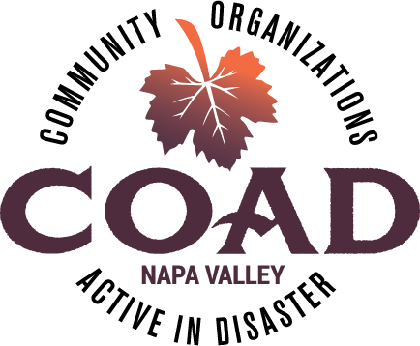
NAPA VALLEY COAD - GENERAL MEETING
Resources for our Community

Thursday, March 19, 2026
9:00 to 10:30 AM

IN PERSON AT
Napa Valley Community Foundation, Community Conference Center
3299 Claremont Way, Suite 2, Napa, CA 94558

AGENDA

- Welcome
  - General Announcements

- DSLC (Disability Services & Legal Center) – Victor Hurtado
  - DSLC General Services
  - Emergency & Preparedness Services

- 211 United Way – Clare Margason
  - 211 General Services
    - AFN Services (Access and Functional Needs) (i.e. people with disabilities, older adults, children, limited English proficiency, and transportation disadvantaged)
  - Preparedness & Emergency Services

- COAD Update
  - Focus in 2026

- Community Connections Update
  - Check out NapaValleyCOAD.org/Connections

- COAD Committee Updates
  - AFN & Older Adults Update & Campaign
  - Children & Family Support Update & Campaign
  - Emergency Financial Assistance - Gift Card Collaborative
  - Food Access Committee

- Member Updates & Next General Meeting – April 28, 2026 at TBD

