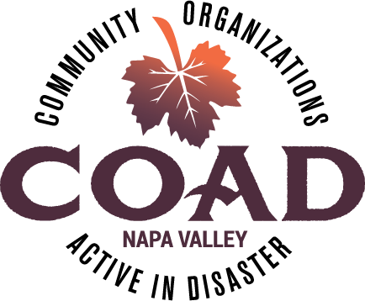
NAPA VALLEY COAD - GENERAL MEETING
Long Term Recovery

Thursday, October 16, 2025
3:30 to 5:00 PM

IN PERSON AT
Napa Valley Community Foundation, Community Conference Center
3299 Claremont Way, Suite 2, Napa, CA 94558

AGENDA

- Welcome
  - General Announcements

- COAD Update
  - Outreach Numbers
  - Introduction: Gio Miramontes, Project Manager
  - Fundraising Results
  - Impact Report

- UASI McPherson Project
  - Developing a one-day CERT Lite with Napa County Fire
  - McPherson Neighborhood Partners Needed

- Community Connections Update
  - Launch Date and Plans
  - Community Connectors and Mentors
  - Website Coming Soon

- COAD Subcommittee
  - AFN & Older Adults Update & Campaign
  - Children & Family Support Update & Campaign
  - Emergency Financial Assistance - Gift Card Collaborative
  - Food Access Committee

- Long Term Recovery
  - What Our Response Protocols
  - When a LTRG is Convened
  - How It is Structured
  - What are the Main Functions
  - Government’s Role
  - Results of 2020 LTRG

- Member Updates & Next General Meeting – January 15, 2025 at TBD

