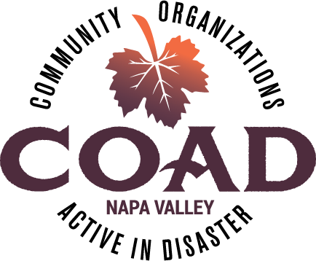
NAPA VALLEY COAD - GENERAL MEETING
UNTIL HELP ARRIVES

Tuesday, July 15, 2025
9:00 to 12 PM

IN PERSON AT
Crosswalk Community Church
2590 First Street, Napa, CA 94558

AGENDA

- Welcome
  - Introductions and General Announcements

- COAD Public Facing Trainings
  - Until Help Arrives
    - Train-the-Trainer – August 12 & 14, 2025 from 8 to 12PM
    - Training for Trainers – September 25, 2025 TBD
  - UASI McPherson Project - Preparados
    - Developing a one-day CERT Lite with Napa County Fire
  - County of Napa Tabletop Exercise
    - Drilling Response of nonprofits in a disaster – August 20, 2025 9 – 1PM

- Community Connections Update
  - Why COAD is a natural choice

- September National Preparedness Month
  - Fundraising for COAD

- COAD Subcommittee
  - AFN & Older Adults Update & Campaign
  - Food Access Committee
  - Children & Family Support Update & Campaign
  - Emergency Financial Assistance - Gift Card Collaborative
  - Mental & Spiritual Health
  - Communication & Language Access
  - Preparedness & Community Resilience
  - Resources
  - Volunteers
  - Animal Welfare

- Next General Meeting – October 16, 2025 at 1PM – Location TBD

