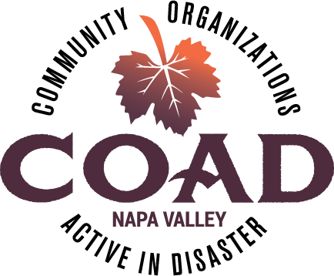

NAPA VALLEY COAD - GENERAL MEETING

Tuesday, January 19, 2021
11:00AM to 12:30PM via Zoom

AGENDA

Meeting Objectives:
- Share COAD and Executive Committee updates
- Share the results of the membership survey and gain additional input
- Provide highlights from the COVID-19 Interim and Wildfire After Action Survey
- Plans for general membership meetings

- Welcome, Ground Rules & Introductions

- Executive committee updates – Michele Grupe

- COAD updates – Celeste Giunta
- Language Access Plan project
- After Action Reports in process
- Training, workshop updates

- COAD Operating Objectives – January 19 to February 16, 2021

- Membership Survey Results – Celeste Giunta

- COVID-19 Interim and Wildfires After Action Survey highlights

- 2021 General Meetings – tentative plan

- Subcommittee and member announcements

Adjournment – NEXT MEETING – FEBRUARY 16, 2021 at 11AM!
- Agenda: County presentation on EOC, evacuation and shelter processes and protocols

